Use Case: Automated Logic Behaviour Assignment in Process Simulate Using .NET API
Objective:
The objective of this tool is to automate the assignment of Logic Behaviour (LB) to resources in Siemens Process Simulate based on predefined data from an Excel sheet. This reduces manual effort and allows Process Simulate engineers to focus primarily on designing kinematics, while the logic setup is handled automatically.
Description:
Resource Extraction :
The tool reads resources from the Process Simulate project that do not yet contain Logic Behaviour.
A list of such resources is displayed in a user-friendly selection popup.
User Selection :
The user selects a resource from the displayed list.
Logic Behaviour Creation :
Once the resource is selected, the tool automatically creates a new Logic Behaviour for it.
Excel Data Integration :
The tool reads resource type information from the provided Excel sheet.
Based on the selected resource, the tool assigns the appropriate Logic Behaviour as defined in the Excel data.
Advantages:
Eliminates repetitive manual steps in attaching Logic Behaviour.
Ensures consistency in Logic Behaviour assignment across multiple resources.
Saves engineering time by automating logic setup, enabling engineers to focus on kinematic design and validation.

Reference Links:
Process Simulate
Create Parameter Reference Link : PL20231017544579710 Documentation 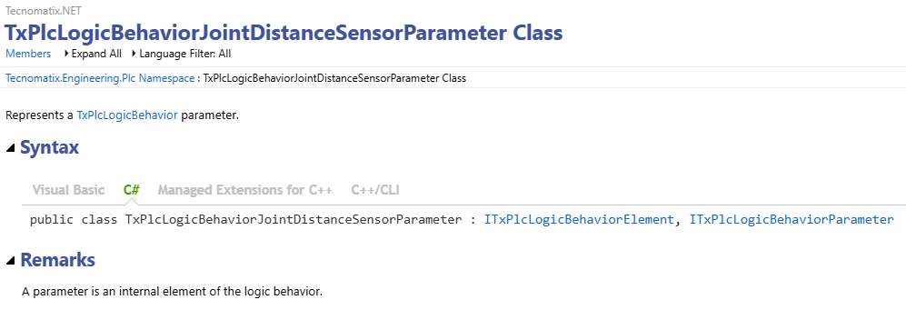
Reference Link For Constant creation Method : Tecnomatix.NET API
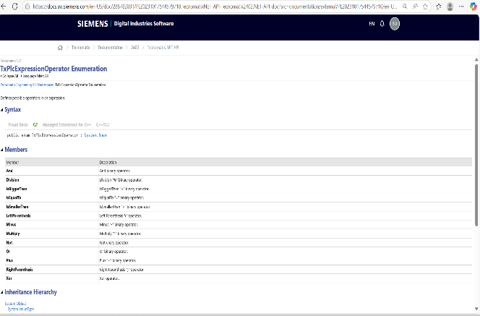
Reference Link For Create Expression: Tecnomatix.NET API
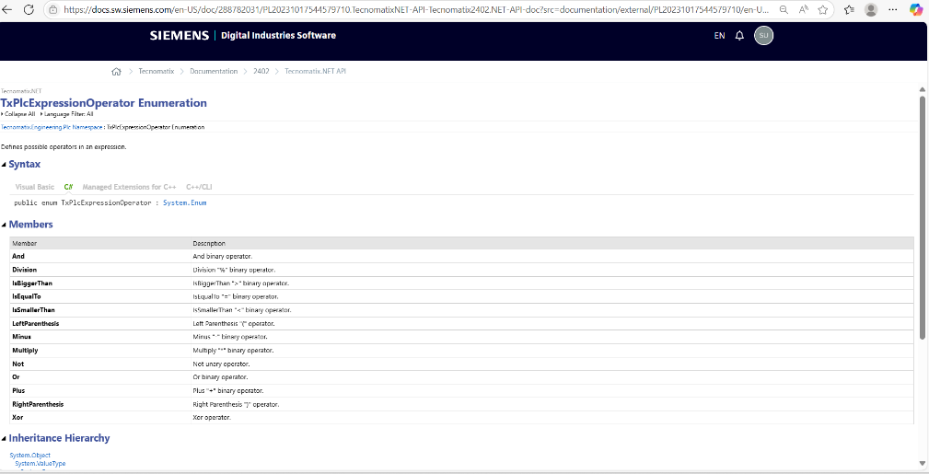

Reference Link for Add Multiple Signal to Entry and Exit:
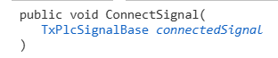
Connect Signal : PL20231017544579710 Documentation :

Flow Chart :

- Create LB using C# script.
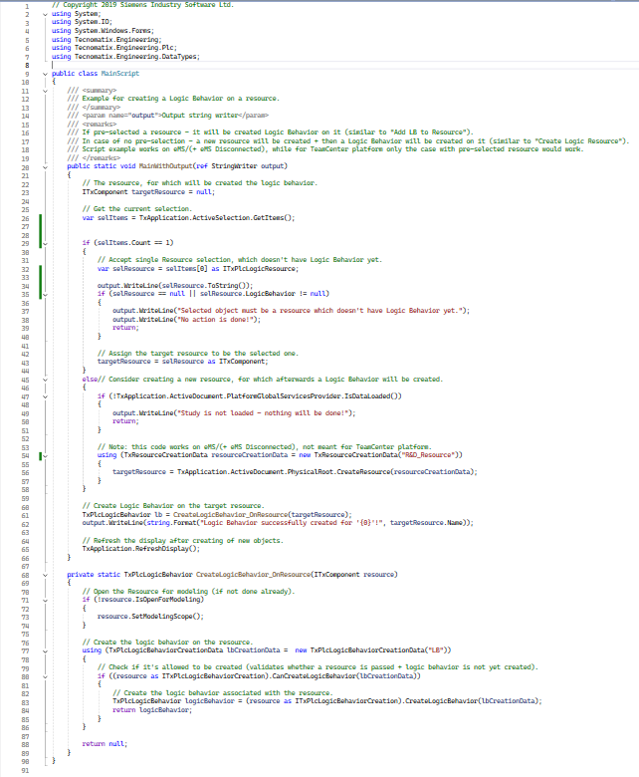

Code Explanation:
- Namespaces and References: (Line No 1 to 7)
Tecnomatix Process Simulate API namespaces.
- Entry Method: MainWithOutput (Line No 20)
Parameter:
ref StringWriter output – Used to capture and return messages about the script execution.
- Variable:
ITxComponent targetResource – Represents the resource (machine/component) for which LB will be created.
- Step 1: Get Current Selection (Line No 26)
var selItems = TxApplication.ActiveSelection.GetItems();
This fetches currently selected items in the Process Simulate UI.

- Step 2: If Exactly One Resource is Selected
if (selItems.Count == 1) (Line No. 29)
It casts the selection to ITxPlcLogicResource (a resource type supporting LB).
If the resource is null or already has LB:
if (selResource == null || selResource.LogicBehavior != null) (Line No. 35)
Prints an error message and stops. Otherwise, assigns this resource to targetResource.

- Step 3: If No Selection (or Multiple Selections) (Line No. 45)

if(!TxApplication.ActiveDocument.PlatformGlobalServicesProvider.IsDataLoaded())
(Line No. 47 to 51)
Checks if a study (model data) is loaded. If not loaded, prints a message and stops.

using (TxResourceCreationData resourceCreationData = new TxResourceCreationData ("R&D_Resource"))
{
targetResource=TxApplication.ActiveDocument.PhysicalRoot.CreateResource(resourceCreationData);
} (Line No. 54 to 57)
Creates a new resource programmatically:
- The new resource will be created and it’s name as parameter name
- Step 4: Create LB for Target Resource
TxPlcLogicBehavior lb = CreateLogicBehavior_OnResource(targetResource);
output.WriteLine(string.Format("Logic Behavior successfully created for '{0}'!", targetResource.Name)); (Line No. 61)

if (!resource.IsOpenForModeling) (Line No. 71)
resource.SetModelingScope();
Ensures resource is open for modelling

if ((resource as ITxPlcLogicBehaviorCreation).CanCreateLogicBehavior
(lbCreationData)) (Line No. 77)
Creates LB and returns its object type.

Result In PS:

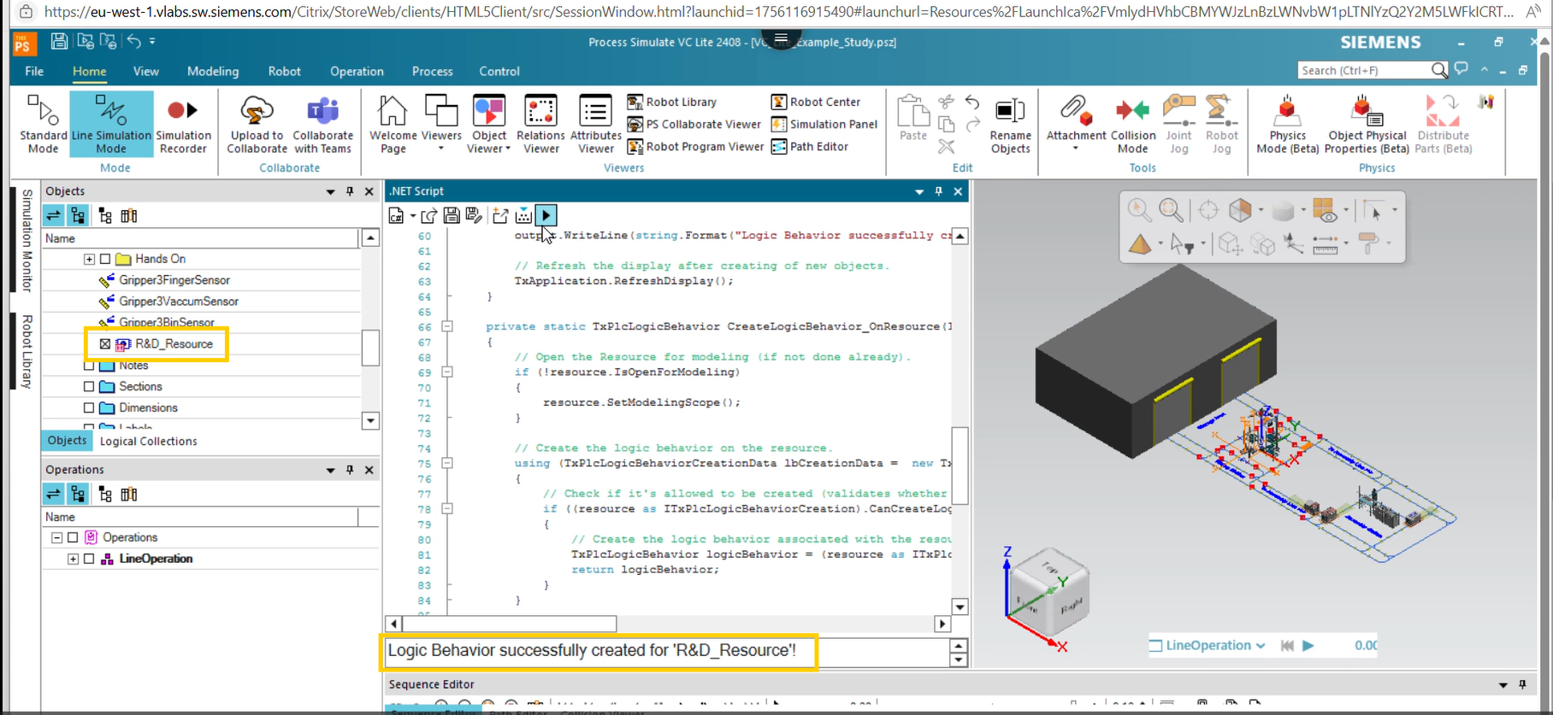
After Successfully run display success message and LB is created.

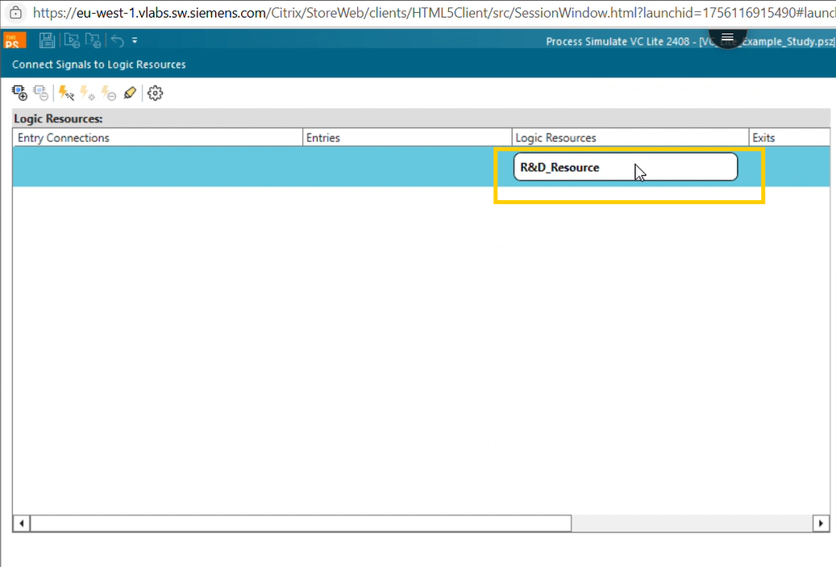

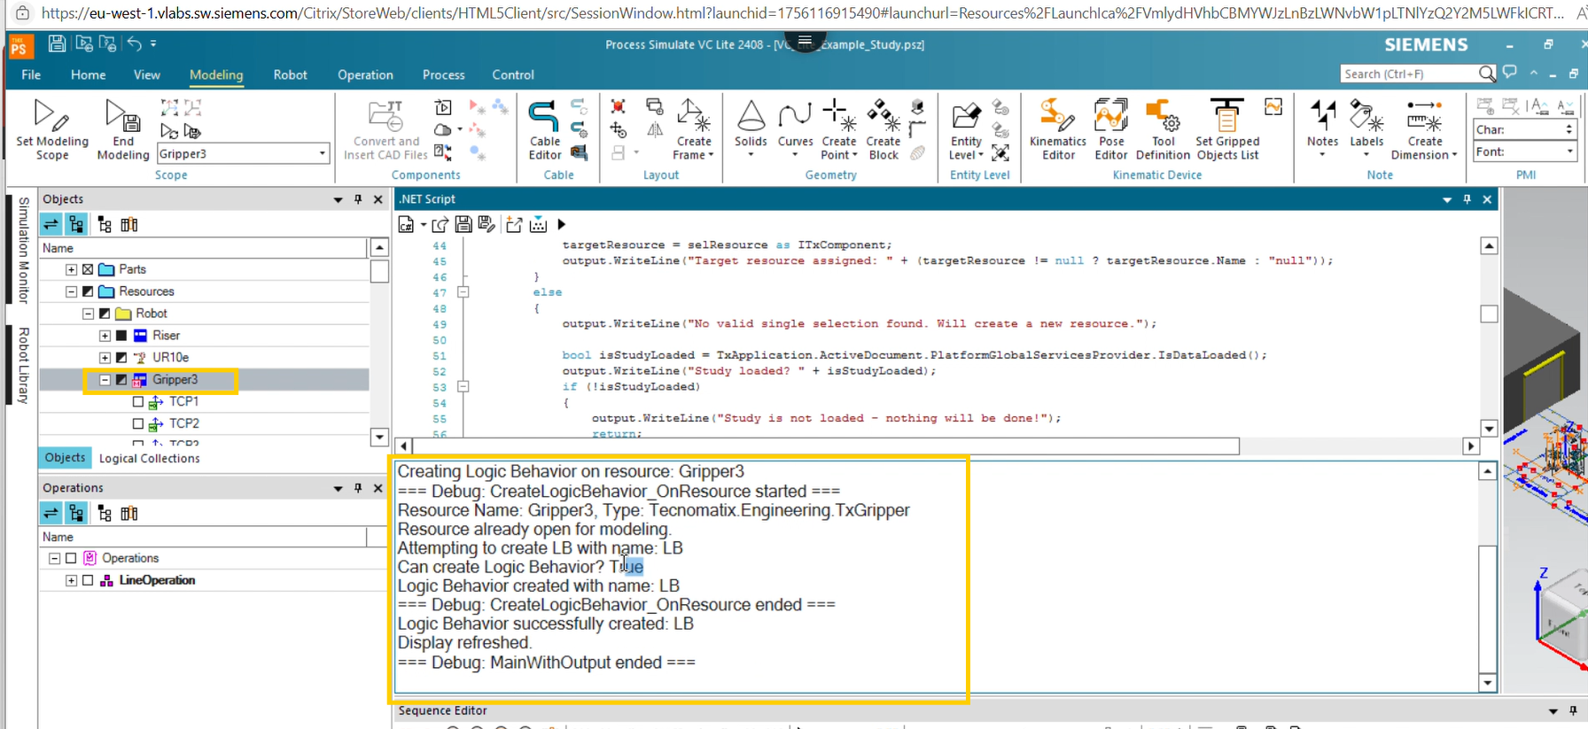
Log for LB creation process.

Create LB Expression:

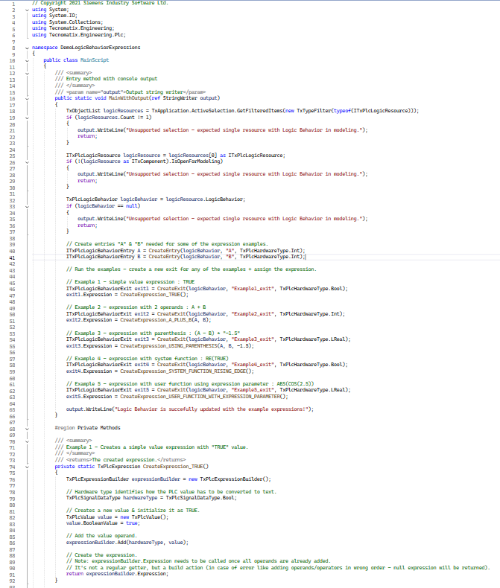
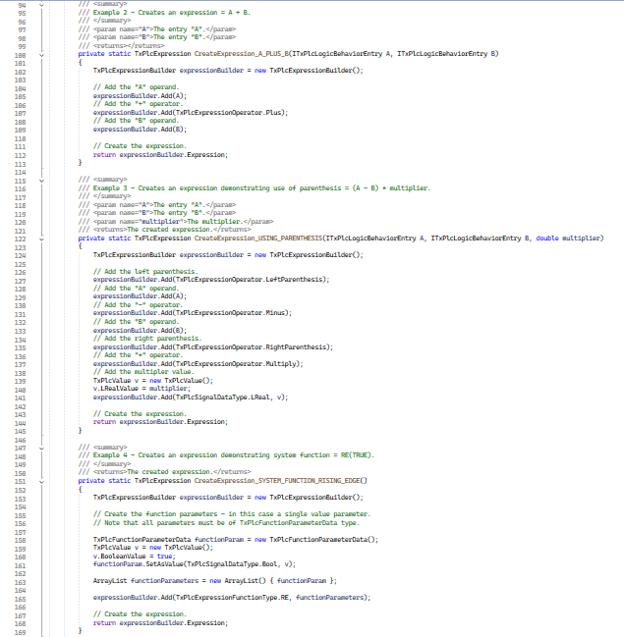
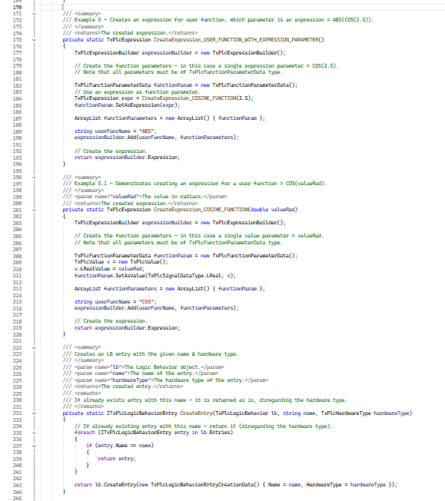

Code Explanation:
- Step 1: Filtered Selection Check:
TxObjectList logicResources = TxApplication.ActiveSelection.GetFilteredItems
(new TxTypeFilter(typeof(ITxPlcLogicResource)));
if (logicResources.Count != 1) (Line No 18 – 23)
Retrieves the currently selected items and filters them to ITxPlcLogicResource (resources that support Logic Behavior).
Validates that exactly one resource is selected; otherwise, prints an error message and stops.

- Step 2: Validation for Modelling Scope:
ITxPlcLogicResource logicResource = logicResources[0] as ITxPlcLogicResource;
if (!(logicResource as ITxComponent).IsOpenForModeling) (Line No 25–30)
Ensures the selected resource is open for modelling, otherwise it prints an error and exits.

- Step 3: Validate Logic Behavior Exists:
TxPlcLogicBehavior logicBehavior = logicResource.LogicBehavior;
if (logicBehavior == null) (Line No 32–37)
- Checks whether the selected resource has an existing Logic Behavior, if not prints an error and exits.

- Step 4: Create LB Entries and Example Expressions:
ITxPlcLogicBehaviorEntry A = CreateEntry(logicBehavior, "A", TxPlcHardwareType.Int);
ITxPlcLogicBehaviorEntry B = CreateEntry(logicBehavior, "B", TxPlcHardwareType.Int);
(Line 39–41)
- Creates or retrieves LB entries as per given name named “A” and “B” for use in example expressions.
- Then creates exits five example and assigns expressions: (Line No 45 - 63)

// Example 1 - simple value expression: TRUE
ITxPlcLogicBehaviorExit exit1 = CreateExit(logicBehavior, "Example1_exit", TxPlcHardwareType.Bool);
exit1.Expression = CreateExpression_TRUE();
// Example 2 - expression with 2 operands: A + B
ITxPlcLogicBehaviorExit exit2 = CreateExit(logicBehavior, "Example2_exit", TxPlcHardwareType.Int);
exit2.Expression = CreateExpression_A_PLUS_B(A, B);
// Example 3 - expression with parenthesis: (A - B) * "-1.5"
ITxPlcLogicBehaviorExit exit3 = CreateExit(logicBehavior, "Example3_exit", TxPlcHardwareType.LReal);
exit3.Expression = CreateExpression_USING_PARENTHESIS(A, B, -1.5);
// Example 4 - expression with system function: RE(TRUE)
ITxPlcLogicBehaviorExit exit4 = CreateExit(logicBehavior, "Example4_exit", TxPlcHardwareType.Bool);
exit4.Expression = CreateExpression_SYSTEM_FUNCTION_RISING_EDGE();
// Example 5 - expression with user function using expression parameter: ABS(COS(2.5))
ITxPlcLogicBehaviorExit exit5 = CreateExit(logicBehavior, "Example5_exit", TxPlcHardwareType.LReal);
exit5.Expression = CreateExpression_USER_FUNCTION_WITH_EXPRESSION_PARAMETER();

Private Helper Methods:
These are utility methods that encapsulate expression and entry/exit creation logic.
- CreateExpression_TRUE (Line No 74):
  - Builds a simple constant Boolean expression TRUE using TxPlcExpressionBuilder.
- CreateExpression_A_PLUS_B (Line No 100):
  - Builds an arithmetic expression with two operands: A + B.
- CreateExpression_USING_PARENTHESIS (Line No 122):
  - Demonstrates parentheses usage: (A - B) * multiplier.
  - Adds parentheses operators explicitly and multiplies by a constant.
- CreateExpression_SYSTEM_FUNCTION_RISING_EDGE (Line No 151):
  - Demonstrates using a system function: RE(TRUE) (rising edge).
  - Builds a function parameter list with TxPlcFunctionParameterData.
- CreateExpression_USER_FUNCTION_WITH_EXPRESSION_PARAMETER (Line 175):
  - Builds a user-defined function expression with another expression as a parameter: ABS (COS (2.5)).
- CreateExpression_COSINE_FUNCTION (Line No 201):
  - Helper for above; creates the COS (2.5) inner expression.
- CreateEntry (Line No 232):
  - Creates or retrieves an LB entry with the given name and hardware type.
  - If already exists, returns the existing entry.
- CreateExit (Line No 256):
  - Creates or retrieves an LB exit with the given name and hardware type.
Result In PS:
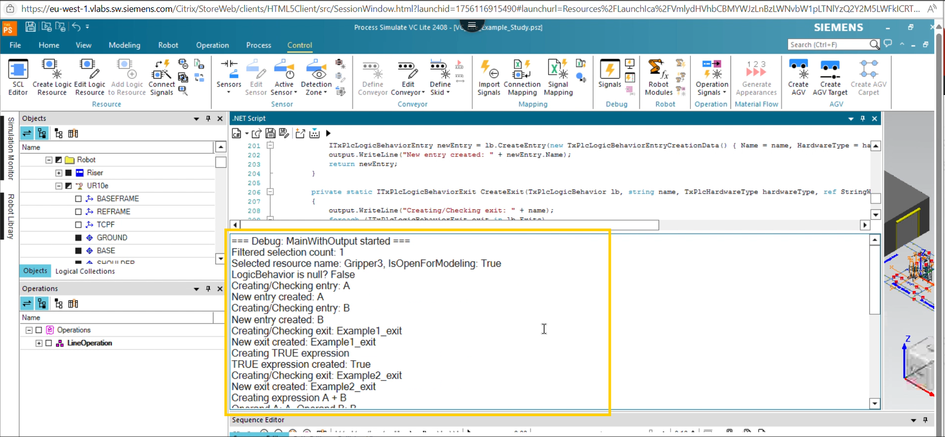
Generated log during run process.

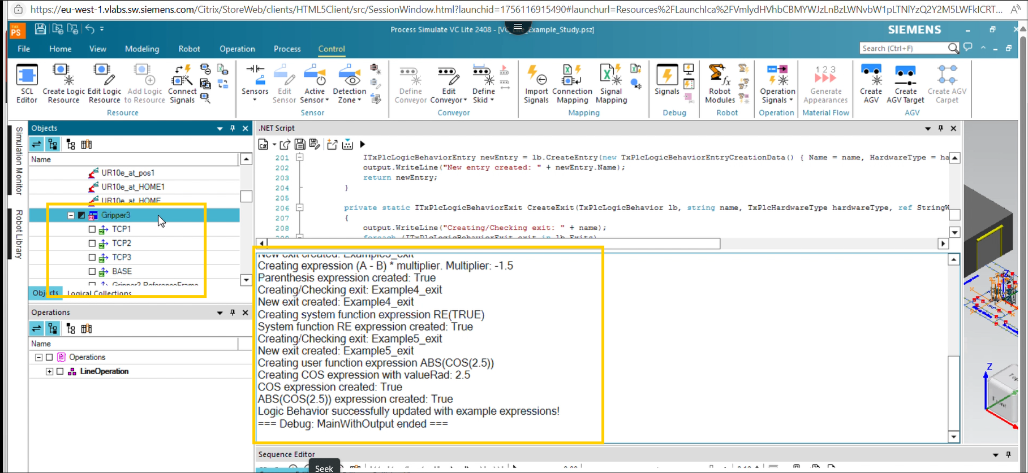
Generated log during run process.

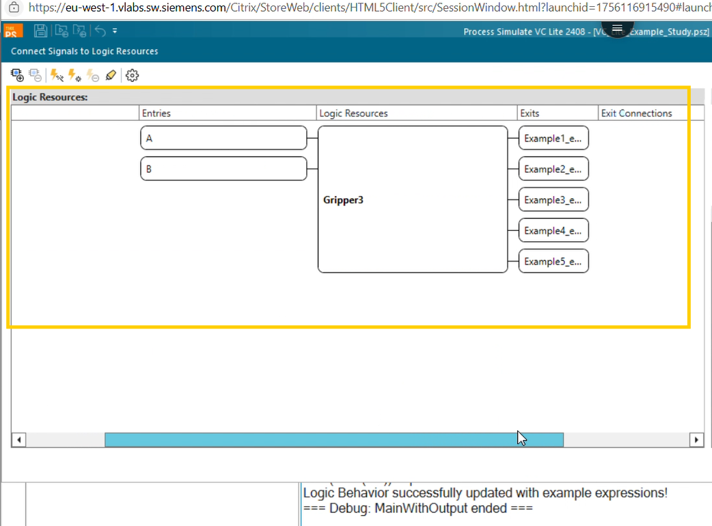
Entries and Exits is assigned as per declare inside C# code.

Expression is added as per mentioned inside C# code.
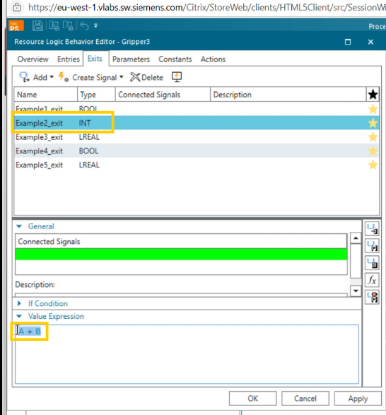
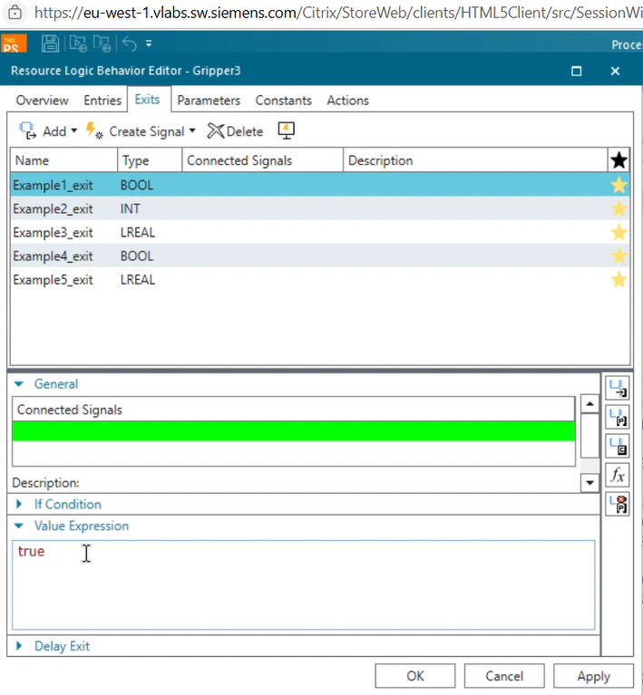
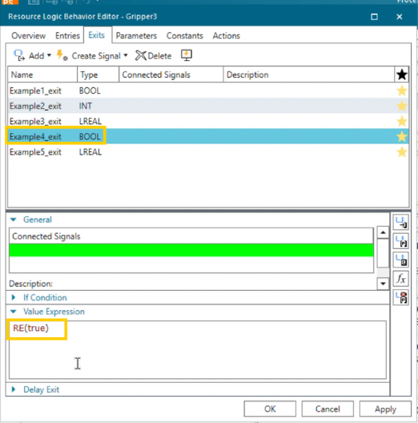
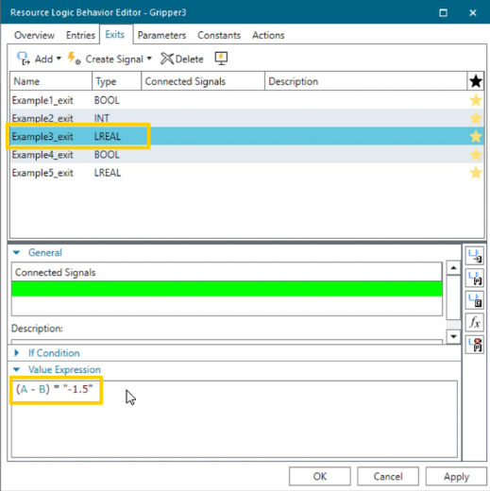
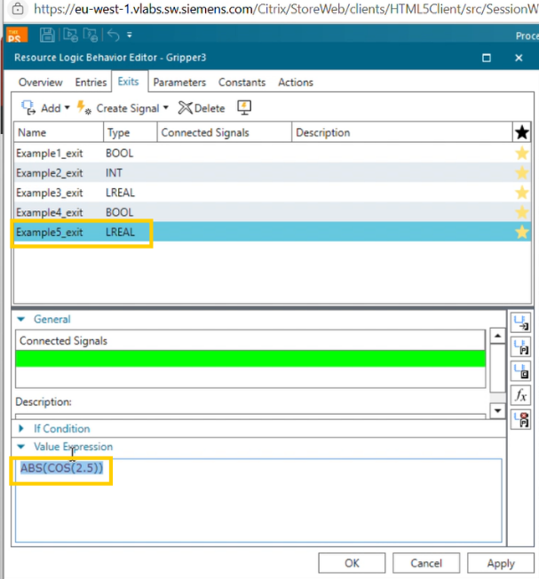

- Create LB Value Parameter:
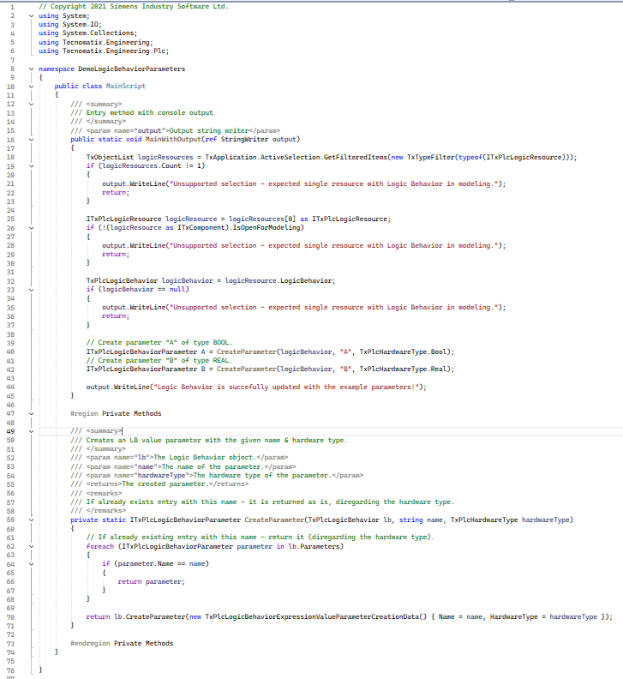

Code Explanation:
- Step 1: Get Selected Logic Resource: (Line No 18)
TxObjectList logicResources = TxApplication.ActiveSelection.GetFilteredItems(new TxTypeFilter(typeof(ITxPlcLogicResource)));
Retrieves the current selection in Process Simulate, filtered to only include logic resources (ITxPlcLogicResource).
- Step 2: Validate Selection Count: (Line No 19 to 24)
if (logicResources.Count != 1) { return; }
Checks that exactly one logic resource is selected, otherwise prints an error and stops execution.
- Step 3: Validate Modelling State: (Line No 26 to 30)
if (!(logicResource as ITxComponent).IsOpenForModeling) {return; }
Casts the selected item to ITxComponent and checks if it’s open for modelling, if not logs an error and exits.
- Step 4: Validate Logic Behavior Exists: (Line No 32 to 37)
TxPlcLogicBehavior logicBehavior = logicResource.LogicBehavior;
if (logicBehavior == null) {return; }
Ensures the selected resource already has a Logic Behavior, if not logs an error and stops.
- Step 5: Create Example Parameters: (Line No 39 to 43)
ITxPlcLogicBehaviorParameter A = CreateParameter(logicBehavior, "A", TxPlcHardwareType.Bool);
ITxPlcLogicBehaviorParameter B = CreateParameter(logicBehavior, "B", TxPlcHardwareType.Real);
Uses a helper method to add two LB parameters named "A" (Boolean) and "B" (Real).
If they already exist, they are reused instead of duplicated.

- Private Helper Method: (Line 59 onwards)
CreateParameter(TxPlcLogicBehavior lb, string name, TxPlcHardwareType hardwareType)
- Iterates over lb.Parameters to check if the parameter already exists.
- If it exists, returns the existing parameter.
- Otherwise, creates a new parameter using:
lb.CreateParameter(new TxPlcLogicBehaviorExpressionValueParameterCreate)

Result In PS:
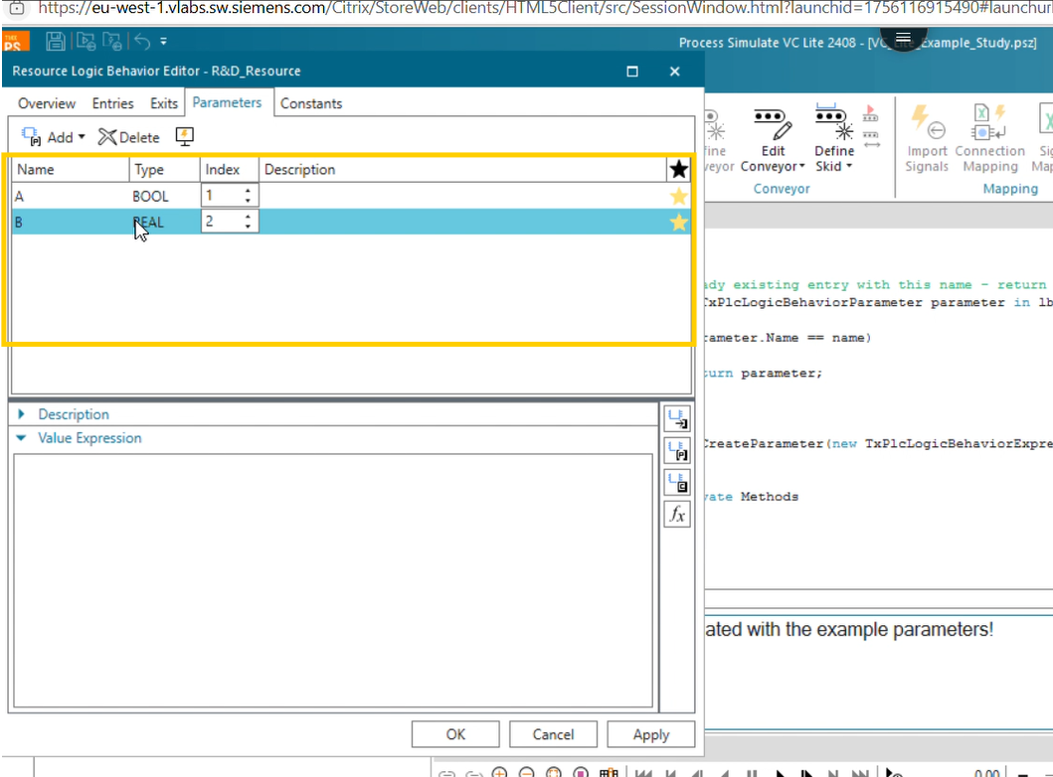

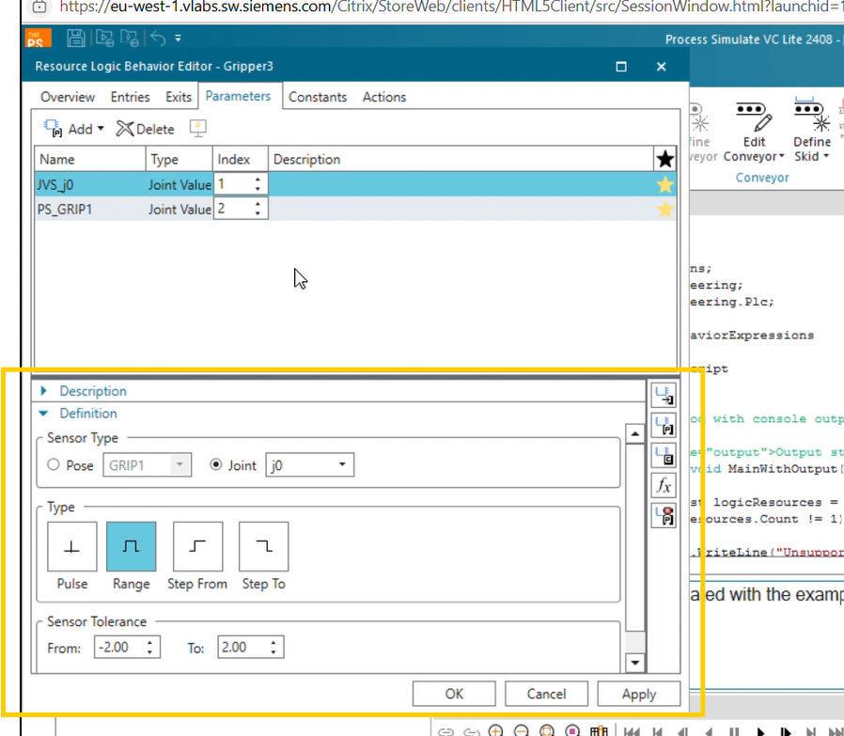
After successfully run parameter is added as per mentioned in C# script.

- Create Joint and Pose Actions
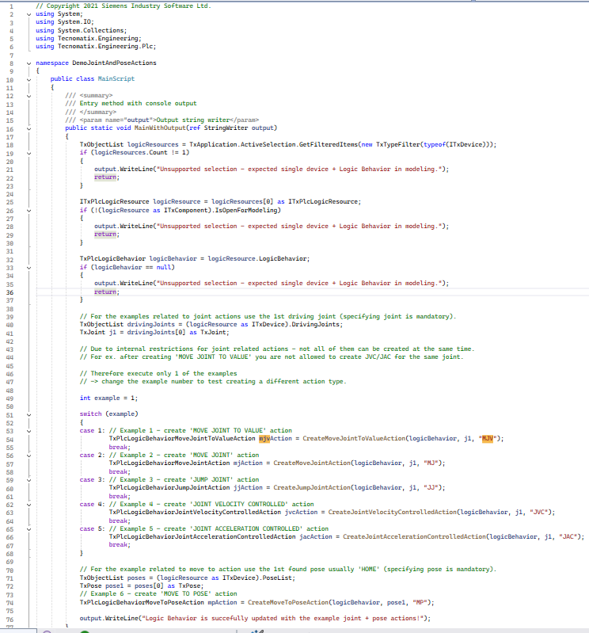
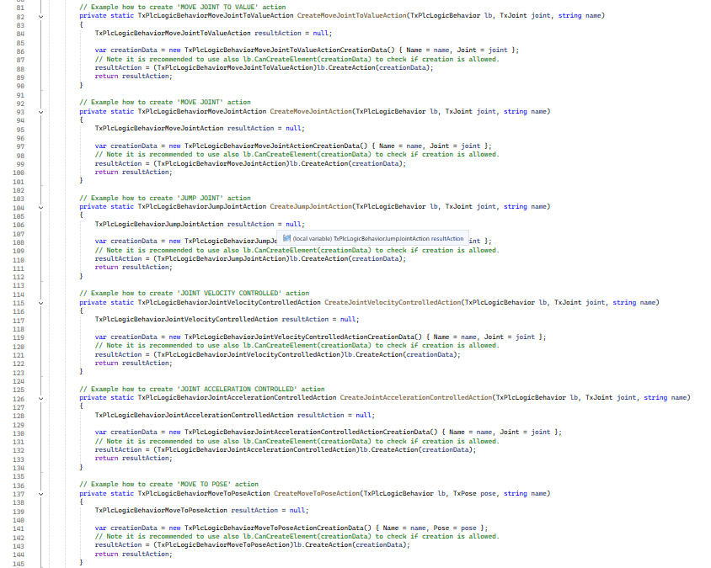

Code Explanation:
- Step 1: Get Current Selection: (Line No 18)
TxObjectList logicResources = TxApplication.ActiveSelection.GetFilteredItems
(new TxTypeFilter(typeof(ITxDevice)));
Fetches currently selected items in the Process Simulate UI, filtered to devices (ITxDevice).

- Step 2: Validate Selection Count: (Line No 19 – 24)
if (logicResources.Count != 1) { return; }
Checks that exactly one device is selected. If not, prints an error and stops.

- Step 3: Validate Modeling State: (Line No 26 – 30)
if (!(logicResource as ITxComponent).IsOpenForModeling) {return; }
Ensures the device is open for modelling; otherwise, prints an error and stops.

- Step 4: Validate Logic Behavior Exists: (Line No 32 – 36)
TxPlcLogicBehavior logicBehavior = logicResource.LogicBehavior;
if (logicBehavior == null) { return; }
Confirms the selected device already has a Logic Behavior, if not prints an error and exits.

- Step 5: Get Driving Joints: (Line No 39 – 41)
TxObjectList drivingJoints = (logicResource as ITxDevice).DrivingJoints;
TxJoint j1 = drivingJoints[0] as TxJoint;
Retrieves the list of driving joints for the device. Takes the first joint (j1) to use in action creation.

- Step 6: Choose and Create a Joint Action Example: (Line No 46 – 68)
The code includes multiple examples for creating different joint-related actions.
int example = 1;
switch (example)
{
case 1: // Example 1 - create 'MOVE JOINT TO VALUE' action
TxPlcLogicBehaviorMoveJointToValueAction mjvAction = CreateMoveJointToValueAction(logicBehavior, j1, "MJV"); break;
case 2: // Example 2 - create 'MOVE JOINT' action
TxPlcLogicBehaviorMoveJointAction mjAction = CreateMoveJointAction(logicBehavior, j1, "MJ"); break;

case 3: // Example 3 - create 'JUMP JOINT' action
TxPlcLogicBehaviorJumpJointAction jjAction = CreateJumpJointAction(logicBehavior, j1, "JJ"); break;
case 4: // Example 4 - create 'JOINT VELOCITY CONTROLLED' action
TxPlcLogicBehaviorJointVelocityControlledAction jvcAction = CreateJointVelocityControlledAction(logicBehavior, j1, "JVC"); break;
case 5: // Example 5 - create 'JOINT ACCELERATION CONTROLLED' action TxPlcLogicBehaviorJointAccelerationControlledAction jacAction = CreateJointAccelerationControlledAction(logicBehavior, j1, "JAC"); break;
}
Each case calls a helper method to create the corresponding action type for the selected joint.
Only one joint-related action is created at a time due to internal API restrictions.

Step 7: Create a Move-To-Pose Action: (Line No 70 – 74)
TxObjectList poses = (logicResource as ITxDevice).PoseList;
TxPose pose1 = poses[0] as TxPose;
TxPlcLogicBehaviorMoveToPoseAction mpAction = CreateMoveToPoseAction(logicBehavior, pose1, "MP");
Retrieves the device's poses (e.g., HOME pose).
Creates a "Move to Pose" logic behaviour action for the first pose.

Private Helper Methods: (Line 81 onwards)
The region contains reusable helper methods for creating various action types:
- CreateMoveJointToValueAction – Creates a Move Joint To Value action.
- CreateMoveJointAction – Creates a Move Joint action.
- CreateJumpJointAction – Creates a Jump Joint action.
- CreateJointVelocityControlledAction – Creates a Joint Velocity Controlled action.
- CreateJointAccelerationControlledAction – Creates a Joint Acceleration Controlled action.
- CreateMoveToPoseAction – Creates a Move To Pose action.
Each method:
- Accepts the logic behaviour (TxPlcLogicBehavior), target joint/pose, and action name.
- Uses creation data objects (TxPlcLogicBehavior...CreationData) to specify parameters.
- Calls lb.CreateAction(...) to add the action to the Logic Behavior.
(Optionally, lb.CanCreateElement(...) can be checked before creation to validate permission.)

Result In PS:
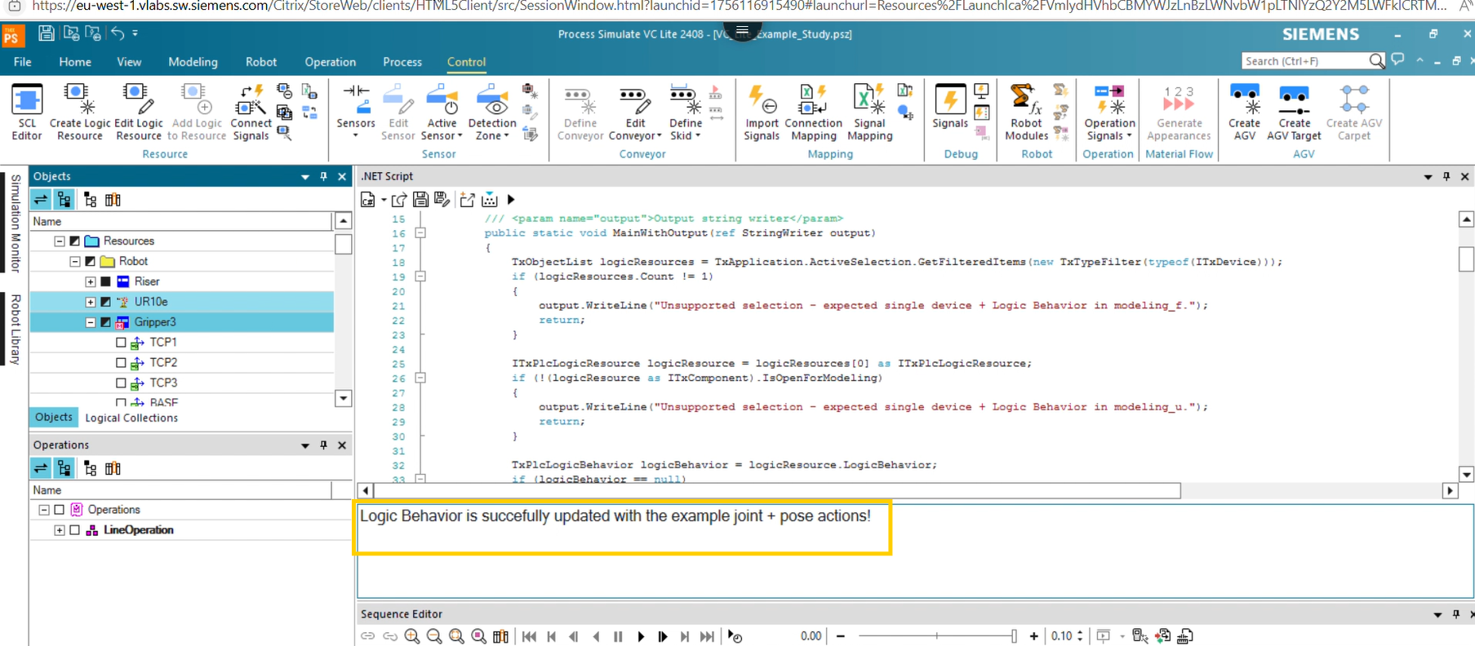
Log message is displayed
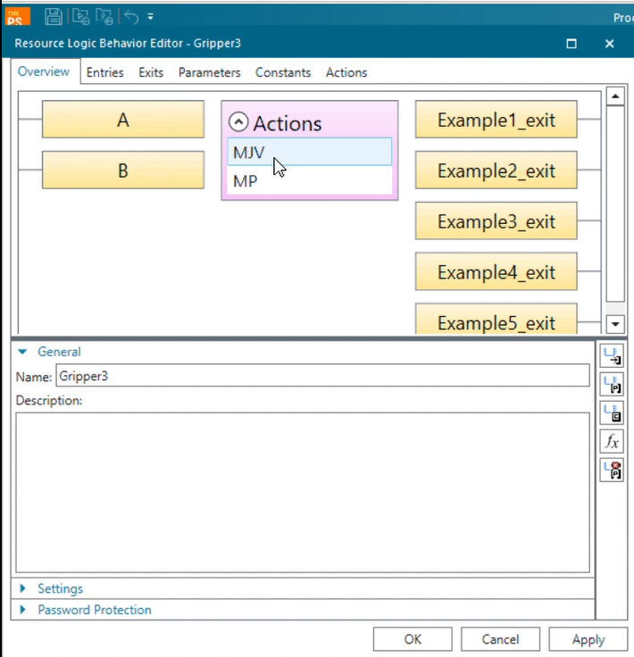
Action is added as per mentioned.

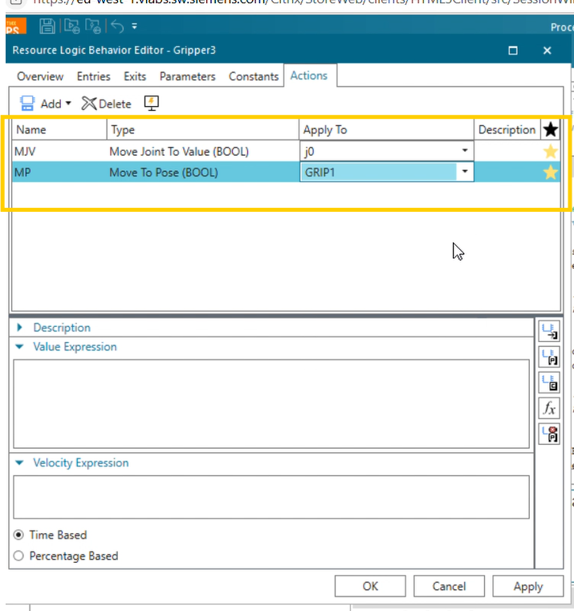

- Create Grip Release Action:
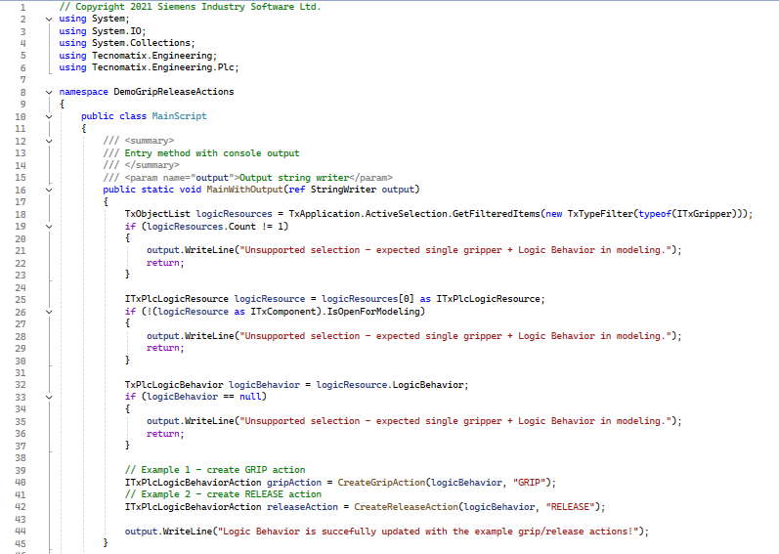
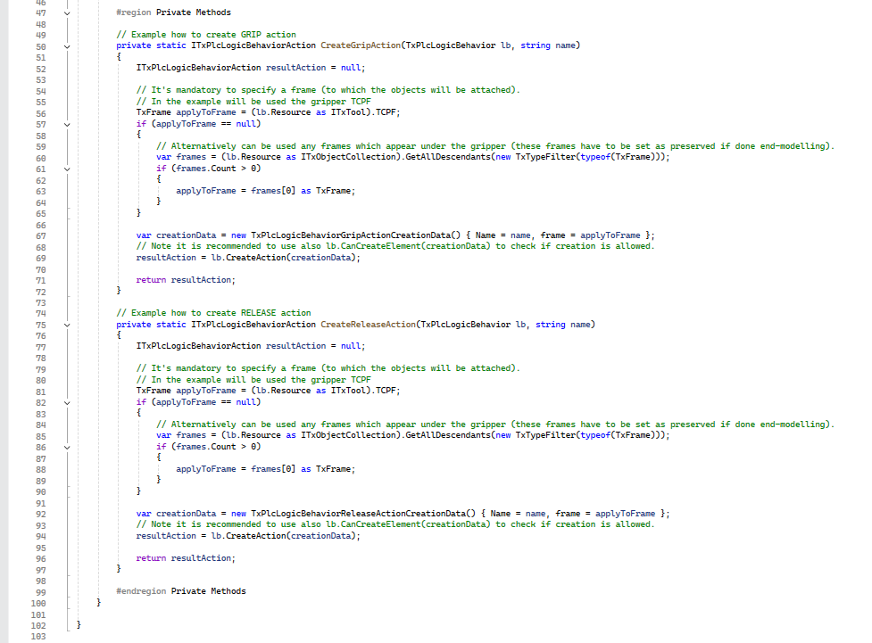
- Step 1: Get Current Selection (Line No. 18)
TxObjectList logicResources = TxApplication.ActiveSelection.GetFilteredItems(new TxTypeFilter(typeof(ITxGripper)));
Fetches currently selected items filtered to ensure only gripper devices are returned.
- Step 2: Validate Selection (Line No. 26–39)
if (logicResources.Count != 1)
{
output.WriteLine("Unsupported selection - expected single gripper + Logic Behavior in modelling.");
return; }

If the count is not equal to 1, prints an error message and stops execution.
ITxPlcLogicResource logicResource = logicResources[0] as ITxPlcLogicResource;
Casts the selected item to ITxPlcLogicResource.
if (!(logicResource as ITxComponent).IsOpenForModeling)
Checks whether the gripper is open for modelling (IsOpenForModeling). If not, prints an error and stops.
TxPlcLogicBehavior logicBehavior = logicResource.LogicBehavior;
if (logicBehavior == null)
Retrieves the LogicBehavior from the resource. If null, prints an error and stops.
At this point, there is exactly one valid gripper resource with a Logic Behavior available for modelling.
- Step 3: Create Grip and Release Actions (Line No. 40–45)
Calls CreateGripAction(logicBehavior, "GRIP") to create a GRIP action.
Calls CreateReleaseAction(logicBehavior, "RELEASE") to create a RELEASE action.
These actions are added to the Logic Behavior of the selected gripper.
- Private Methods: (Line No. 50 onwards)
CreateGripAction and CreateReleaseAction:
- Both methods determine the frame where the grip/release action will apply.
- Create the respective action using:
new TxPlcLogicBehaviorGripActionCreationData() { Name = name, frame = applyToFrame }
Use lb.CanCreateElement(creationData) before CreateAction to validate if the action can be added.

Result In PS:
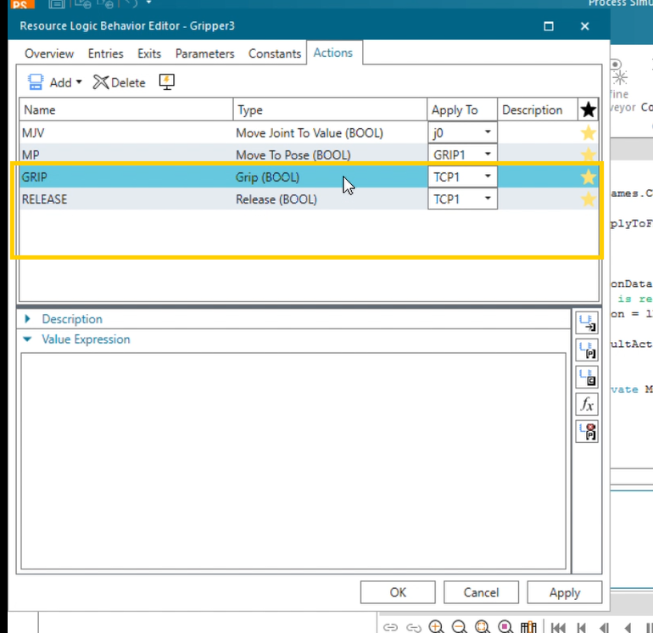
After successfully run the C# script “GRIP” and “RELEASE” action is added

- Signal Address Update C# Script
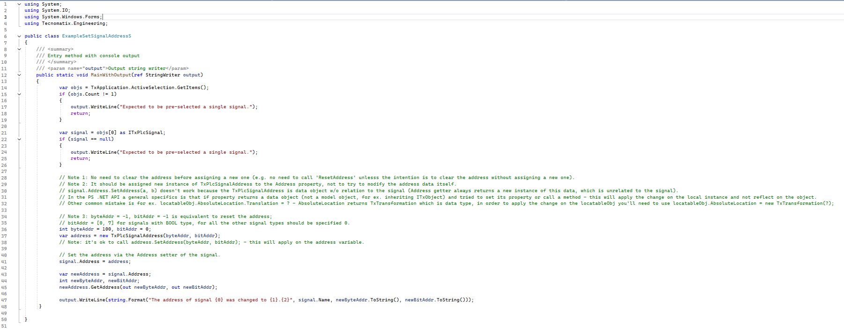

Code Explanation:
- Step 1: Get Current Selection (Line No. 3)
var objs = TxApplication.ActiveSelection.GetItems();
Fetches the currently selected items in the Process Simulate UI.
- Step 2: Validate Selection Count (Line No. 4 – 8)
if (objs.Count != 1){
output.WriteLine("Expected to be pre-selected a single signal.");
return;
}
Checks that exactly one object is selected, otherwise logs an error and exits.
- Step 3: Validate Object Type (Line No. 10 – 14)
var signal = objs[0] as ITxPlcSignal;
if (signal == null)
Casts the selected object to ITxPlcSignal. If it's not a PLC signal, logs an error and exits.

- Step 4: Create and Assign New Address (Line No. 32 – 37)
int byteAddr = 5000, bitAddr = 0;
var address = new TxPlcSignalAddress(byteAddr, bitAddr);
signal.Address = address;
Creates a new signal address with byte 5000 and bit 0, then assigns it to the signal via its Address property.
- Step 5: Read Back and Confirm Address (Lines No. 39 – 43)
var newAddress = signal.Address;
int newByteAddr, newBitAddr;
newAddress.GetAddress(out newByteAddr, out newBitAddr);
output.WriteLine(string.Format("The address of signal {0} was changed to {1}.{2}", signal.Name, newByteAddr.ToString(), newBitAddr.ToString()));
Retrieves and prints the updated address (for confirmation) to the output writer.

Result In PS:
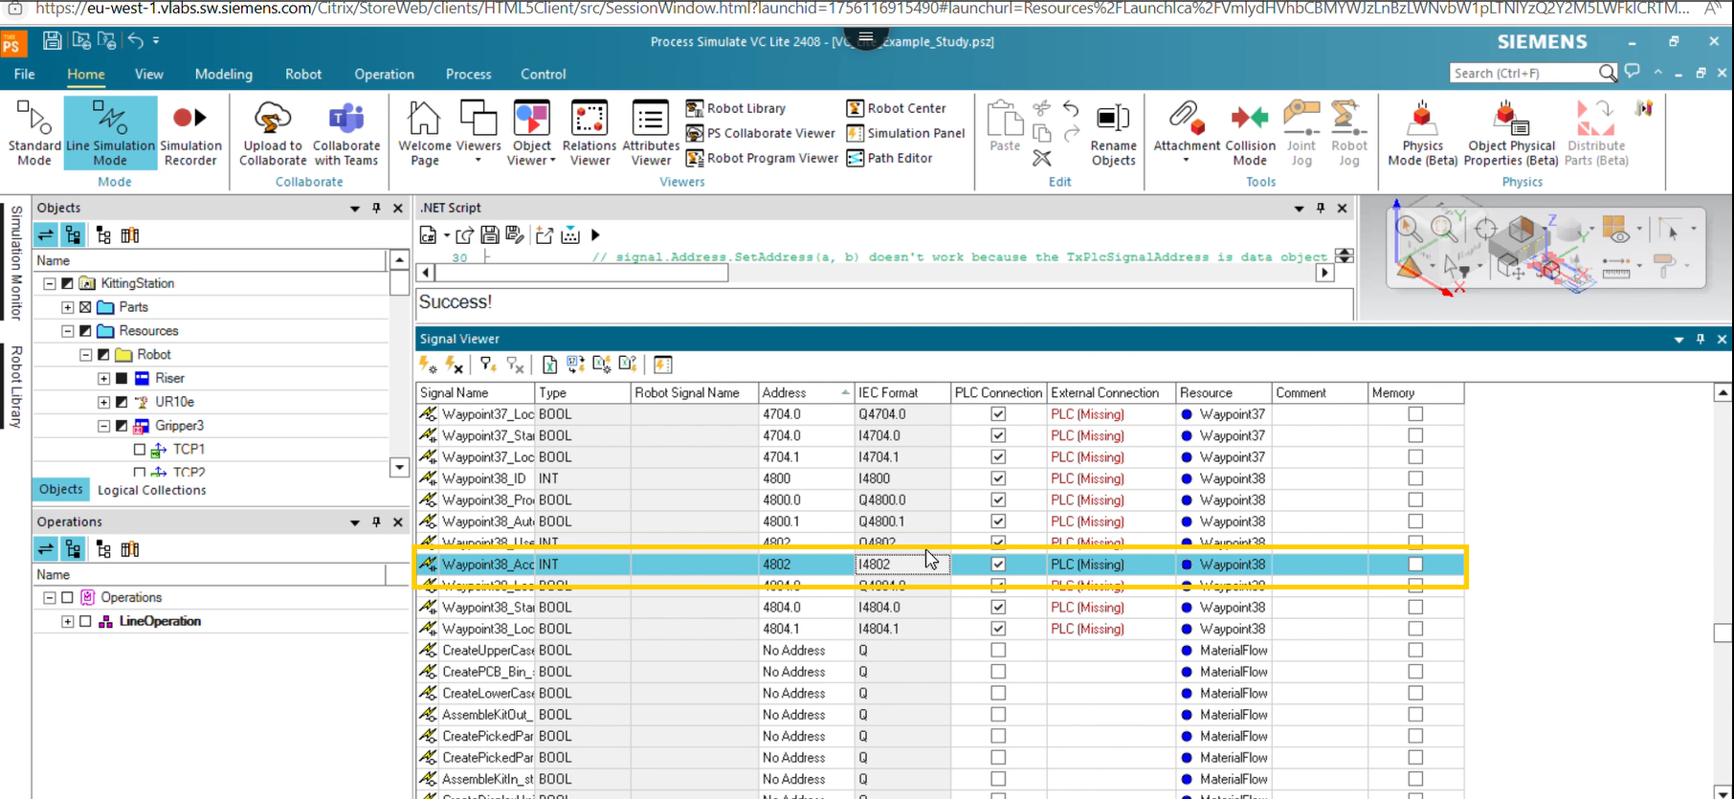
Before Update Signal Address.
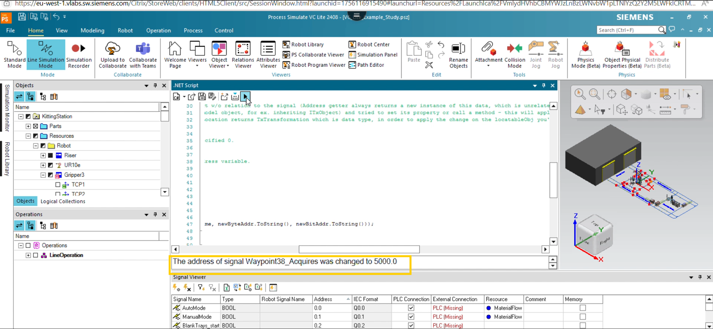
After successfully running the process success log is displayed.

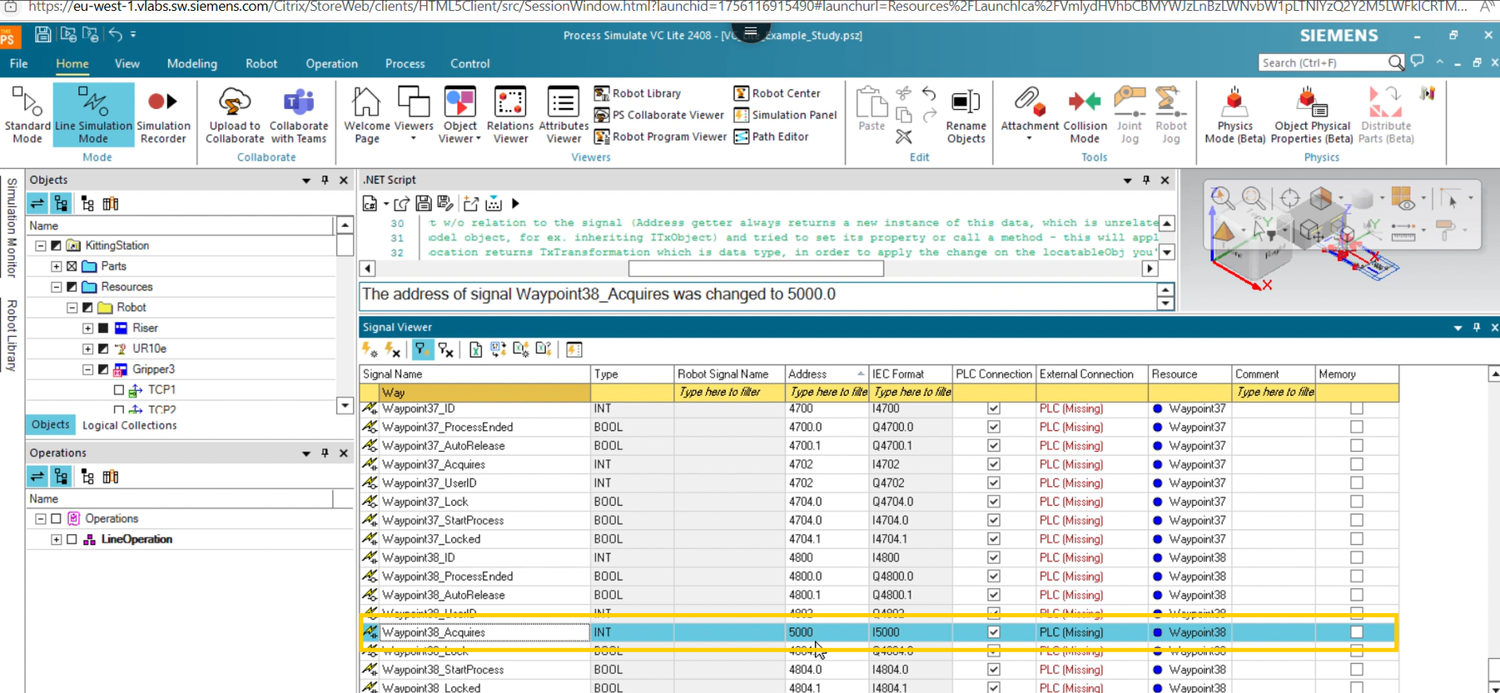
Address is updated as per mentioned in C# script

From_R&D.7z Folder Structure Information.
After Extract folder contains below files
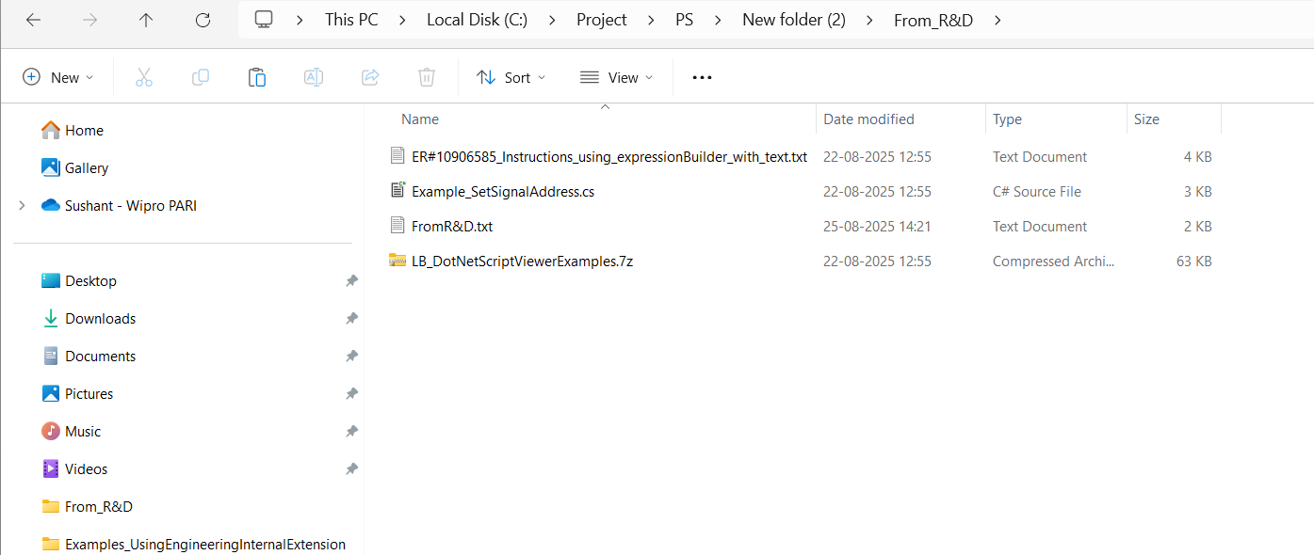
ER#10906585_Instructions_using_expressionBuilder_with_text.txt file contains below pseudo code methods information.
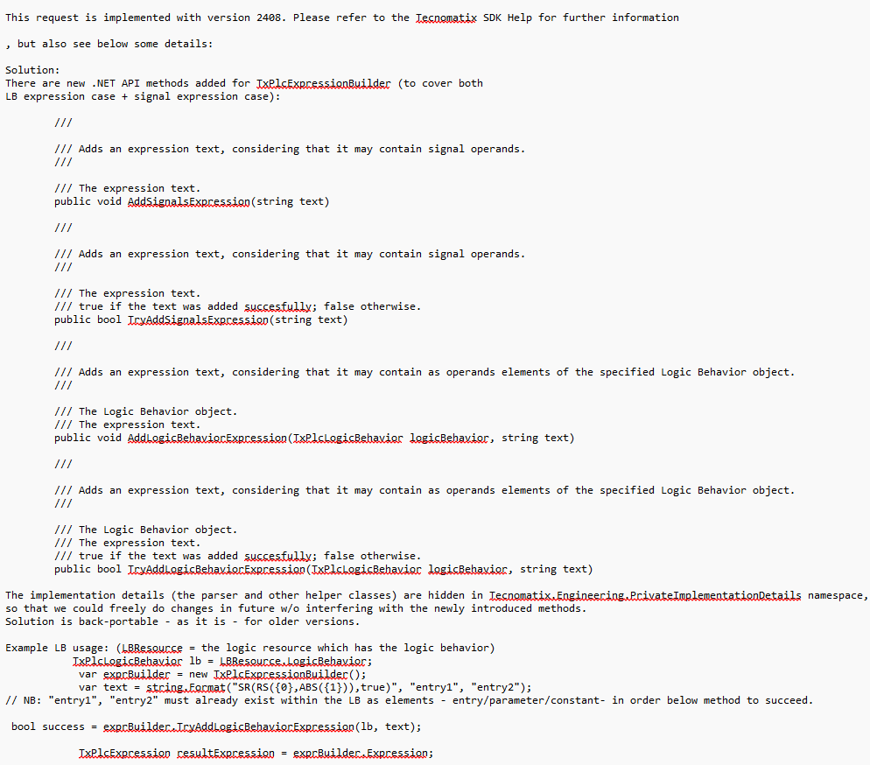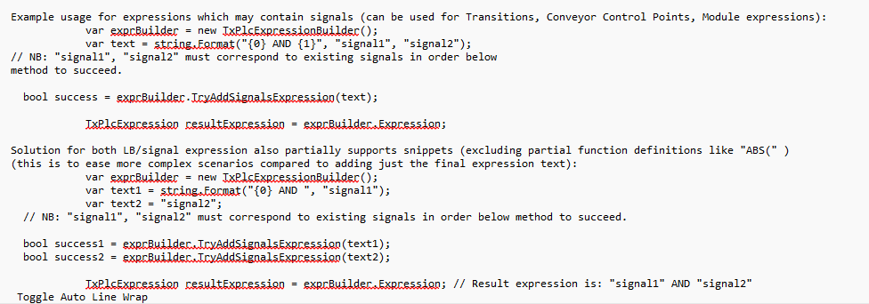

Example_SetSignalAddress.cs contains below Update signal address functionality C# code

FromR&D.txt contains overview related to provided functionality
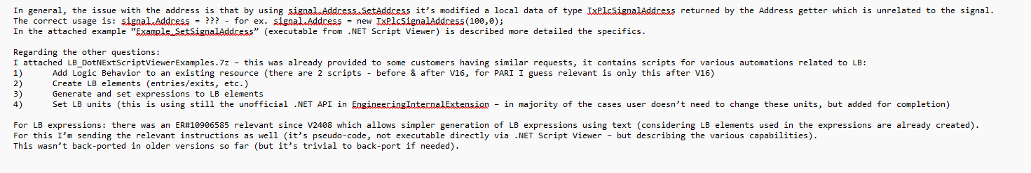

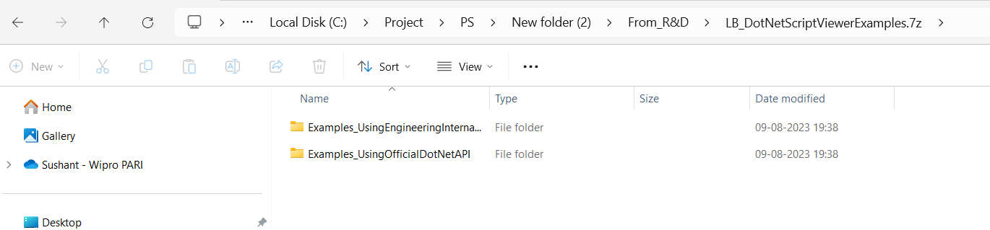
In LB_DotNetScriptViewerExamples.7z zip folder contains, Examples_UsingEngineeringInternalExtension, Examples_UsingOfficialDotNetAPI sub folders.

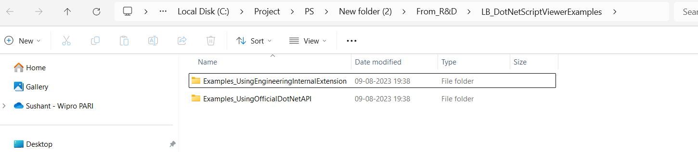
In Examples_UsingEngineeringInternalExtension, contains below two files Instructions_AddReference_EngineeringInternalExtension.png, and SetLBUnits.cs

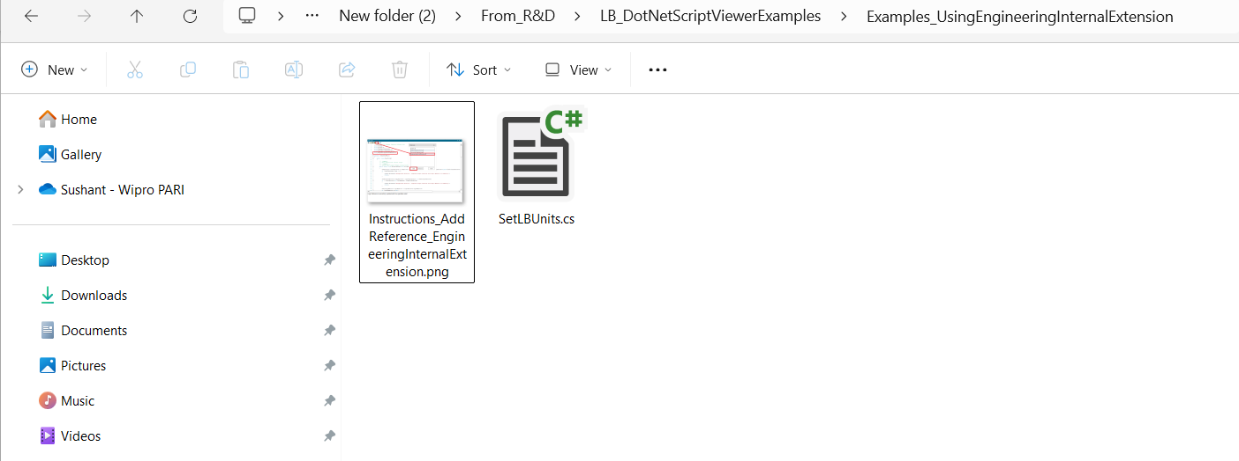
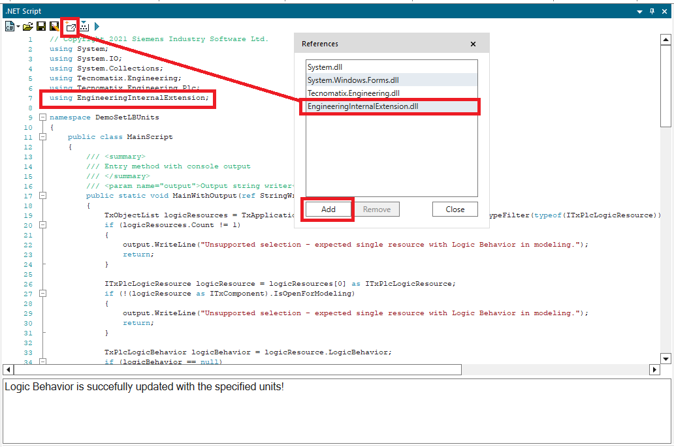
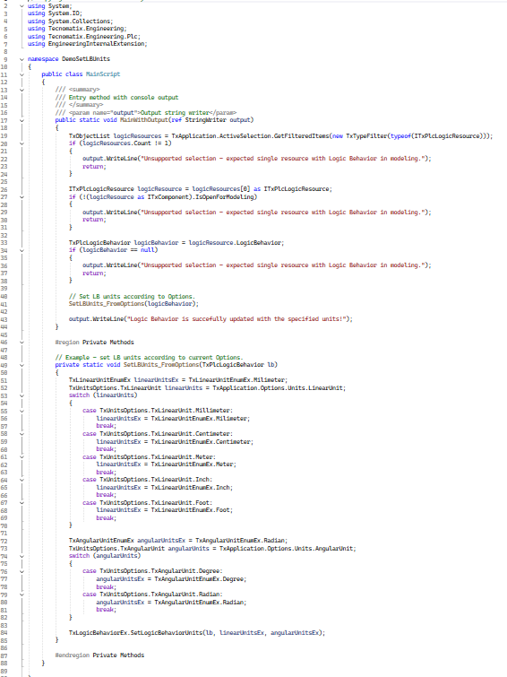

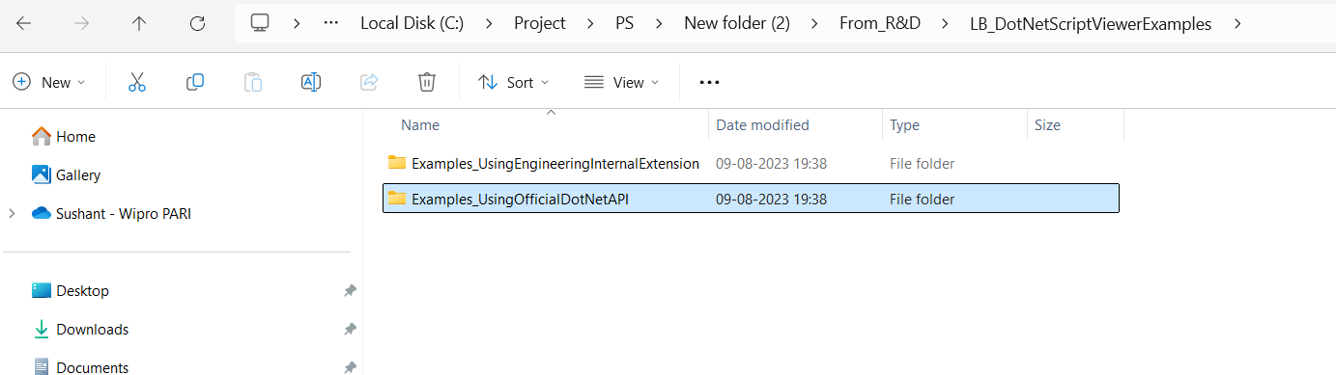
In Examples_UsingOfficialDotNetAPI contains below C# functionality “.cs” files 1. CreateGripReleaseActions.cs, 2. CreateJointAndPoseActions.cs 3. CreateJointValueSensorParameter_Updated.cs 4. CreateLB_AboveV16.cs 5.CreateLB_V16.cs 6.CreateLBValueParameters.cs 7.LBExpressionExamples.cs

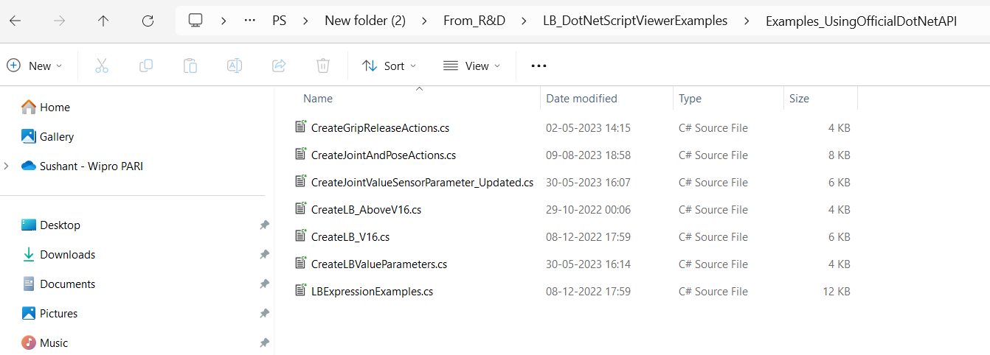

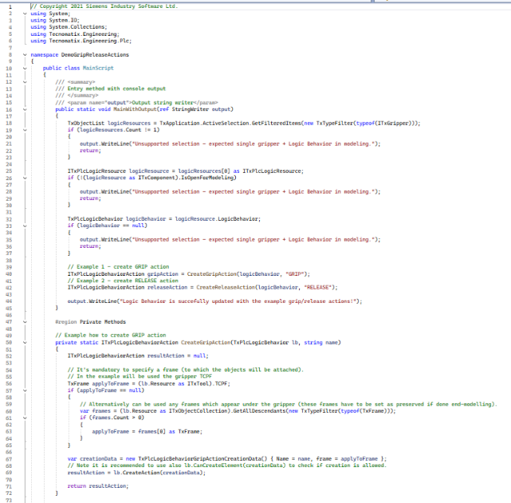
  - “CreateGripReleaseActions.cs” file contains C# code about create Grip and Release action using C# script.
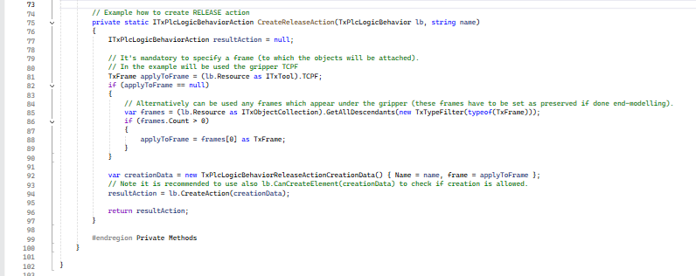

  - “CreateJointAndPoseActions.cs” file contains C# code about create Joint and Pose Action using C# script.

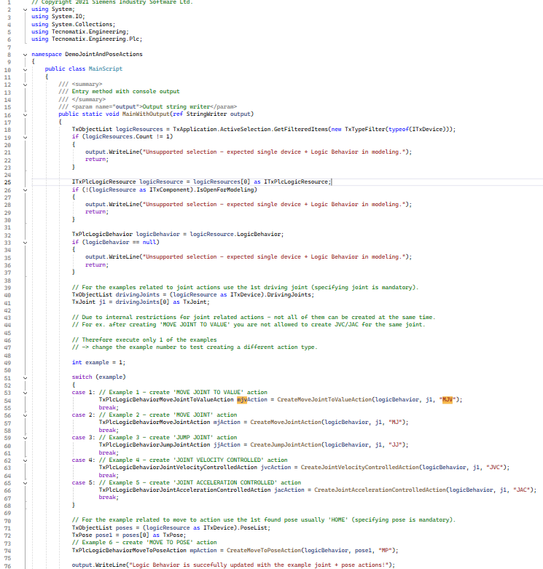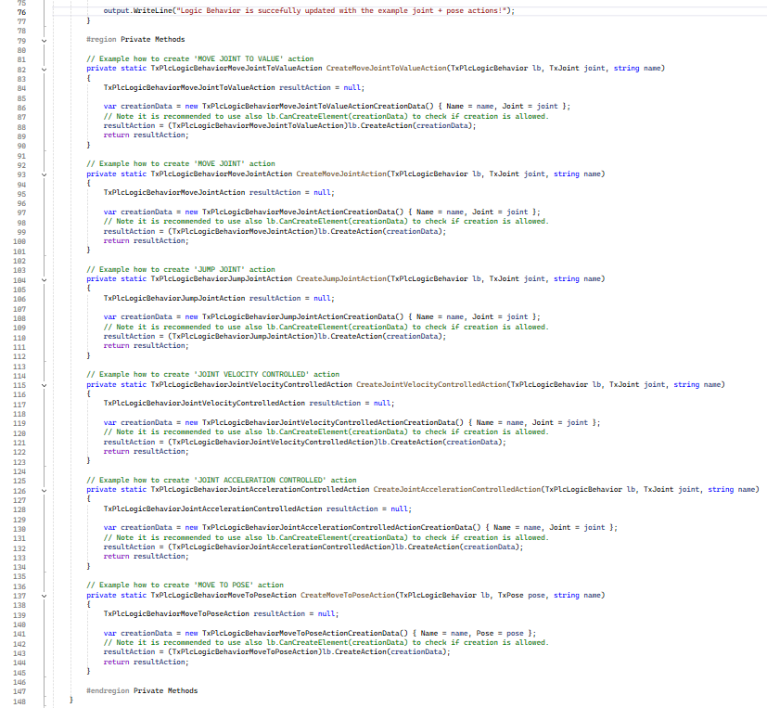

  - “CreateLB_AboveV16.cs and CreateLB_V16.cs” contains C# code about create LB using C# script.

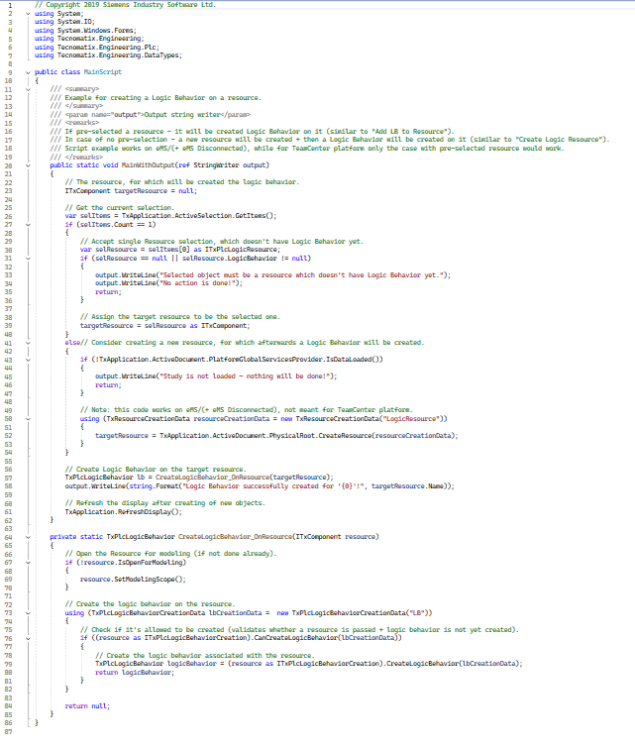

  - “CreateLBValueParameters.cs” contains C# code about create value parameter for LB using C# script.

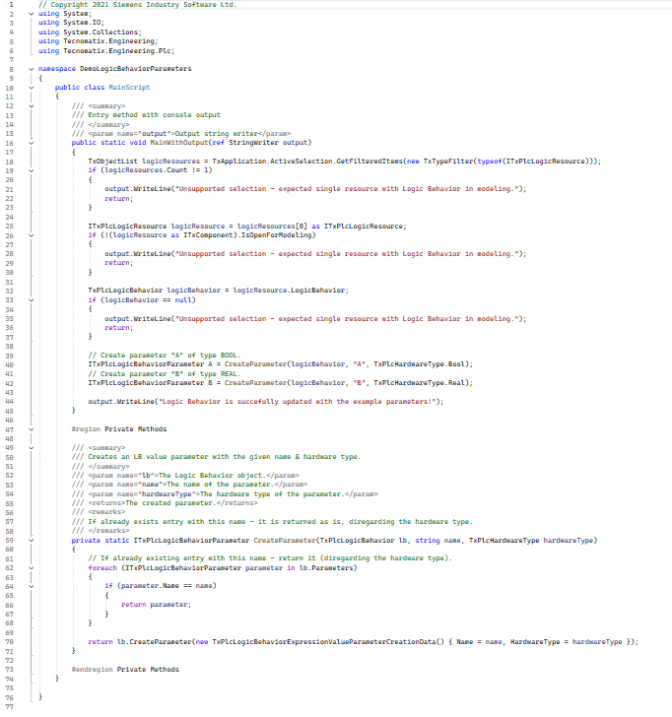

  - “LBExpressionExamples.cs” contains C# code about add Expression in the LB variable.

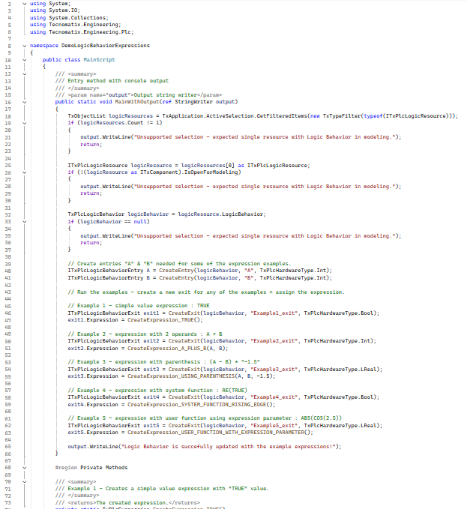
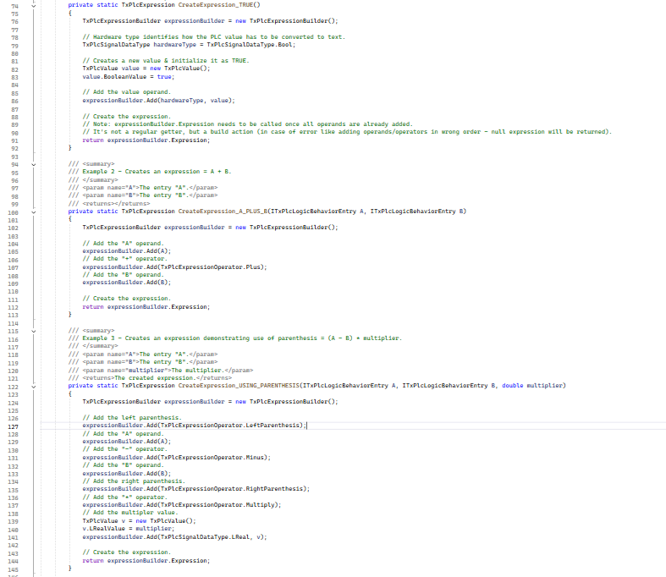

Dynamically setting the modelling and create logic behaviour.
Apply Foreach loop and pass element trough it, access the select element for compare, if it match then add the further logic to create LB.
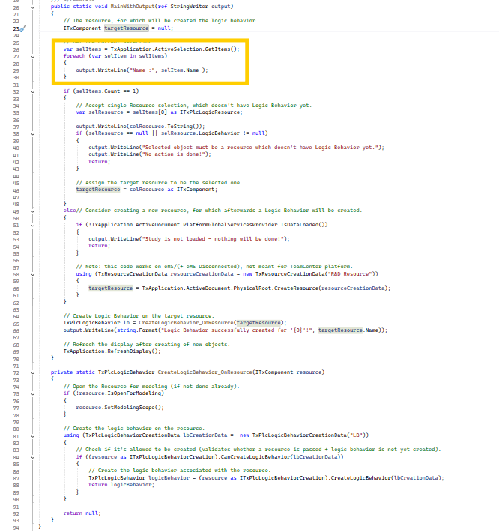

Updated Methods:
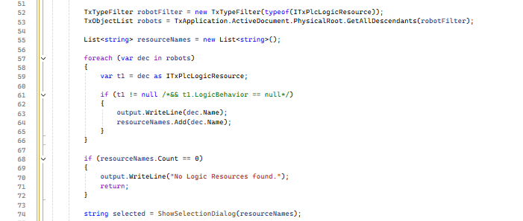
Read Resource from PS project using “TxTypeFilter” and “TxObjectList” object
Call ShowSelectionDialog() method for displaying Pop up to the user

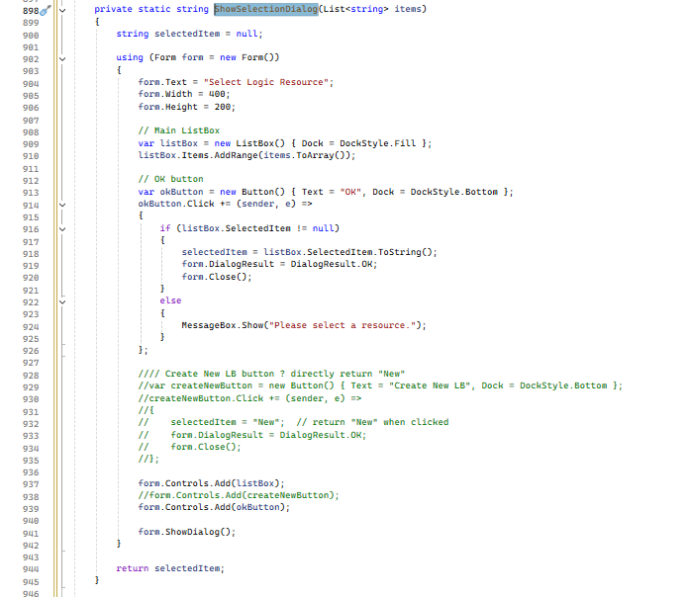

Result In PS:
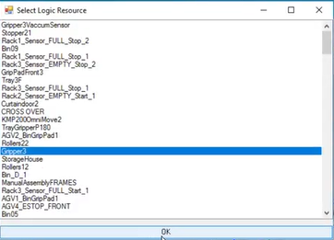

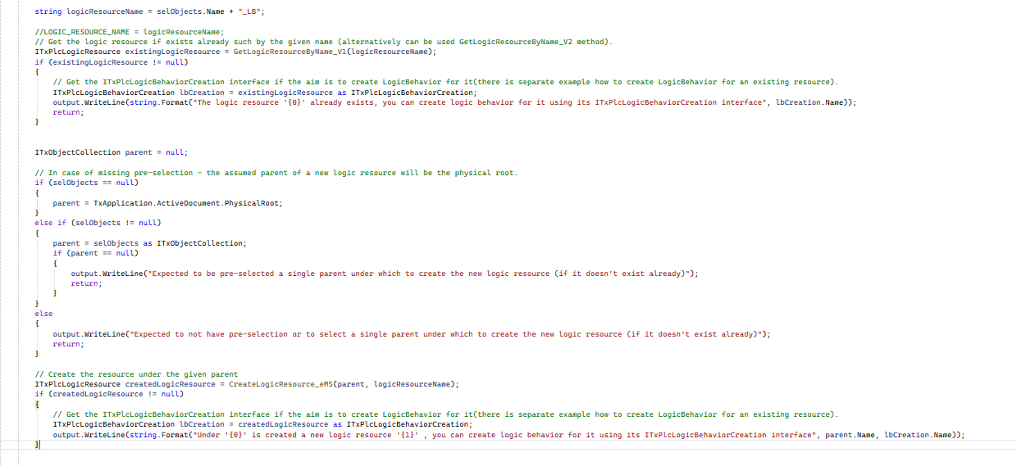
Create Logic Behaviour For Selected Resource using ITxPlcLogicBehaviorCreation() object.

Result In PS:
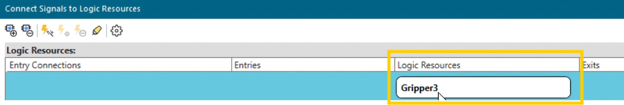

Created Logic Behaviour In PS

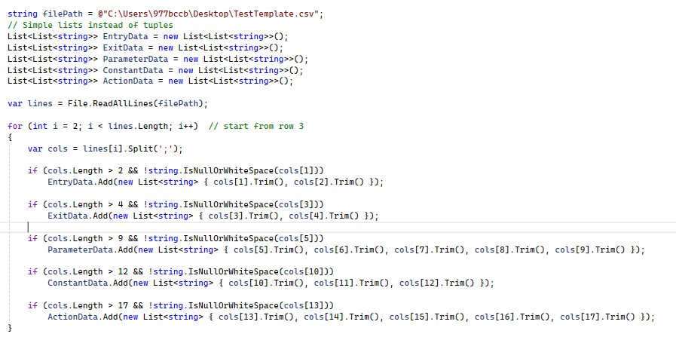
Read the Excel Data and store in the list as per the type.
List<List<string>> EntryData = new List<List<string>>();
Contains data related to Entry type from excel.
List<List<string>> ExitData = new List<List<string>>();
Contains data related to Exit type from excel.
List<List<string>> ParameterData = new List<List<string>>();
Contains data related to Parameter type from excel.
List<List<string>> ConstantData = new List<List<string>>();
Contains data related to Constant type from excel.
List<List<string>> ActionData = new List<List<string>>();
Contains data related to Action type from excel.
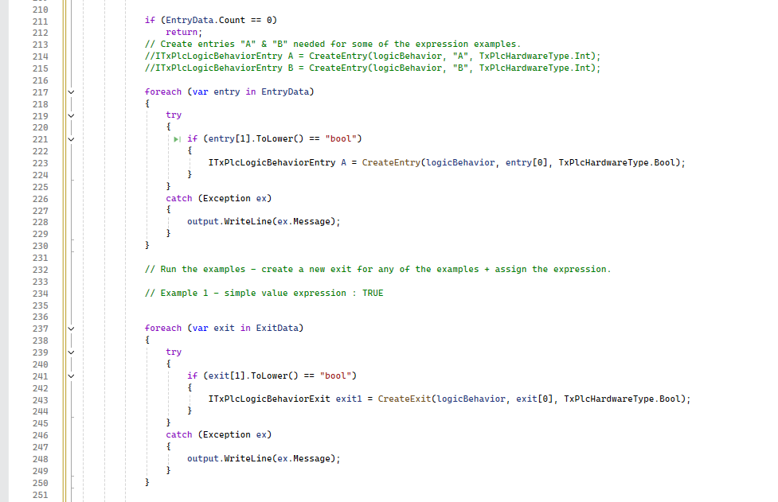
Pass List contains Entry and Exit data one by one using loop and call method
“CreateEntry” for entry creation and “CreateExit” for exit creation.

Result In PS:
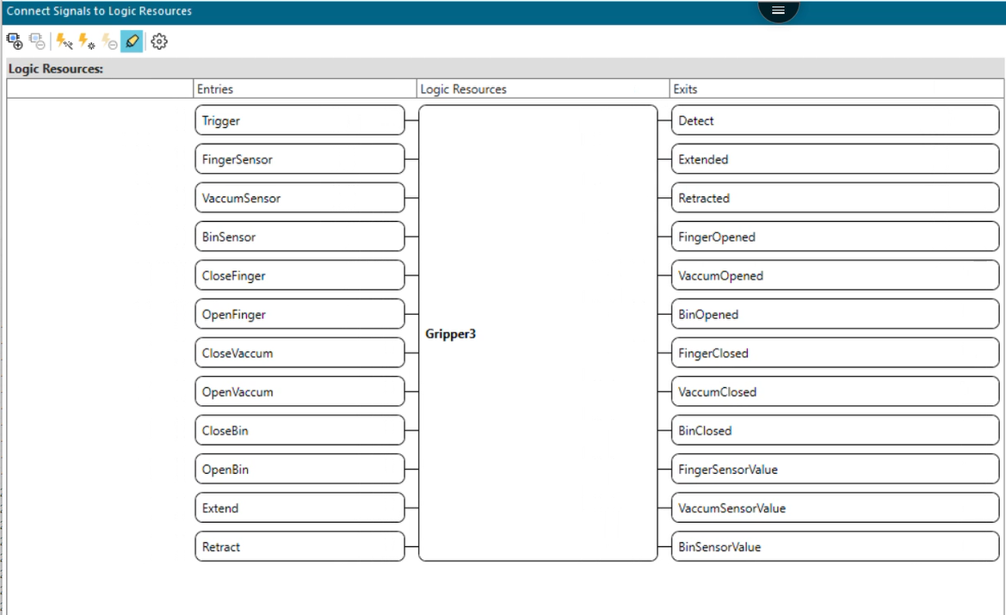

Add Multiple Signal to Entry and Exit:
Reference Link :
Connect Signal : PL20231017544579710 Documentation :
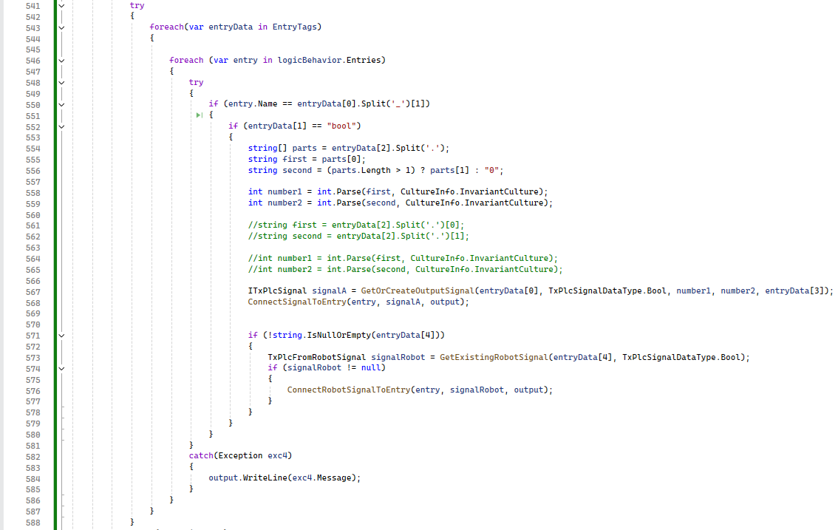
Using For loop iterate the user provided signal data pass the data to GetOrCreateOutputSignal and ConnectSignalToEntry for create and connect PLC signals, for robot signal connection call GetExistingRobotSignal and ConnectRobotSignalToEntry methods.
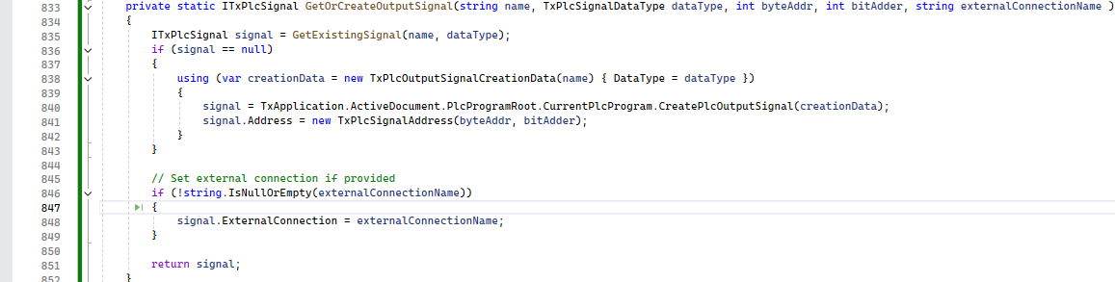
GetOrCreateOutputSignal methods contains logic to create the new PLC signal using “CreatePLCSignalMethod” and assign address “TXPLCSignalAddress” object.
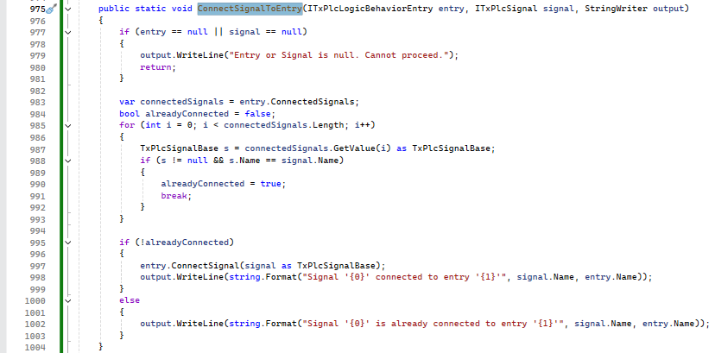
Using ConnectSignal(TxPlcSignalBase) object connect the signals.
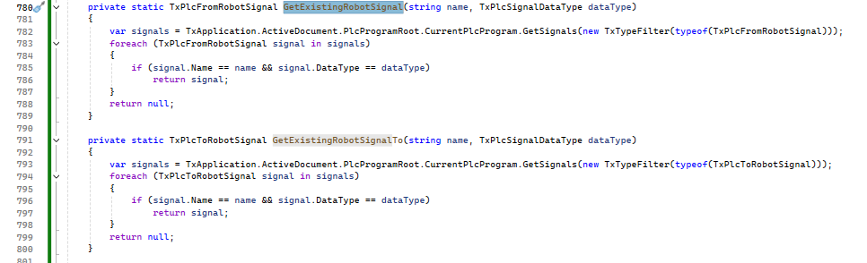
Using “TxPlcFromRobotSignal” and “TxPlcToRobotSignal” object find the robot signal from PS project.
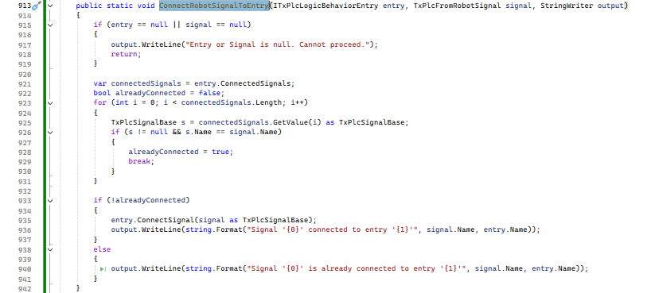
In above code use “ConnectSignal(TxPlcSignalBase)” for signal connection.
Result In PS:
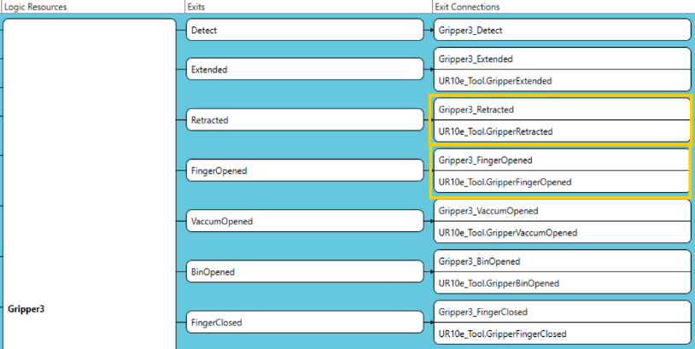
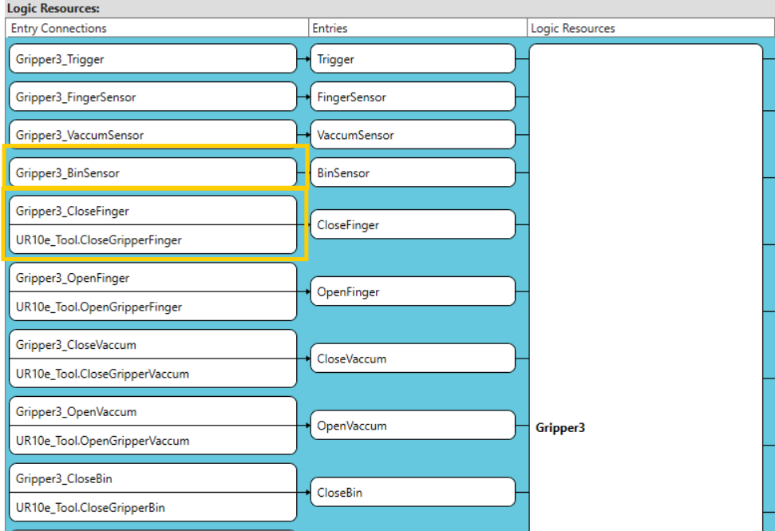
Connected Signals To Entry. Connected Signal To Exit.

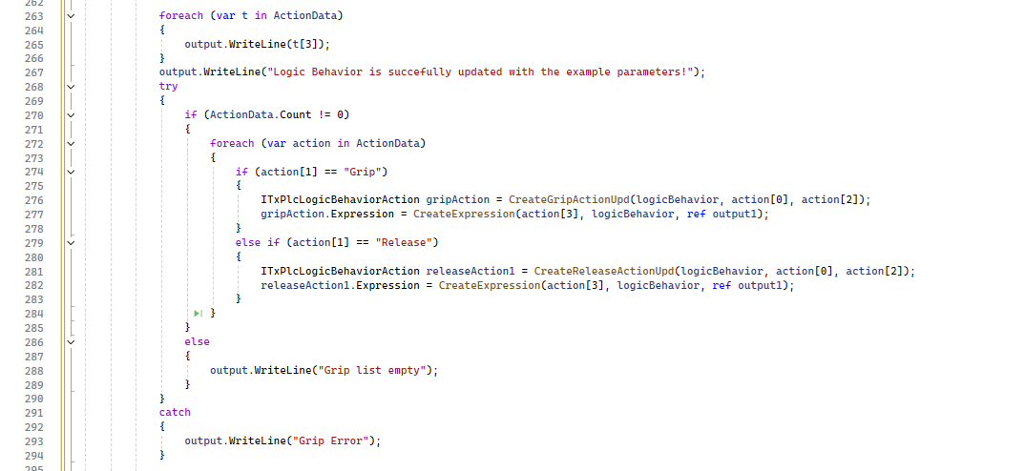
Pass the action parameter from list using loop to method “CreateActions”
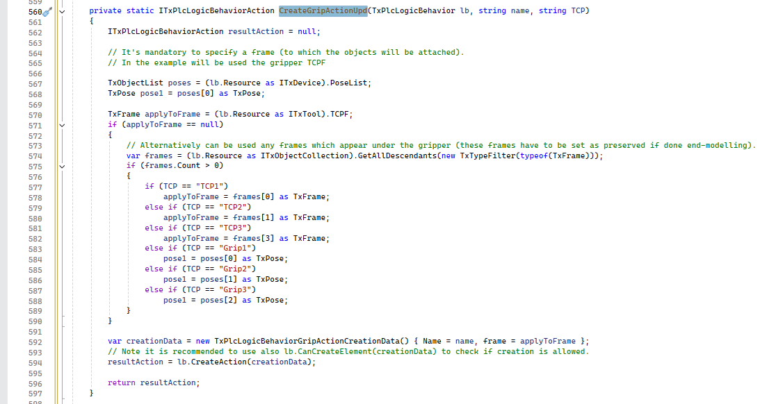
In CreateAction method check the TCP type using if condition and pass to
TxPlcLogicBehaviorActionCreation() object.

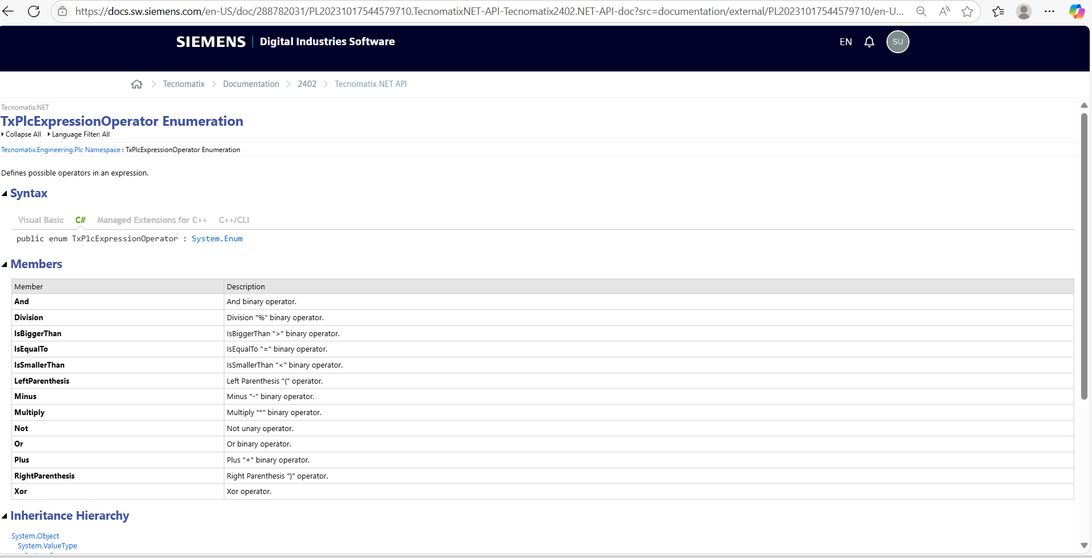
From above table reference, create expression for action using user provided excel.
Reference Link : Tecnomatix.NET API
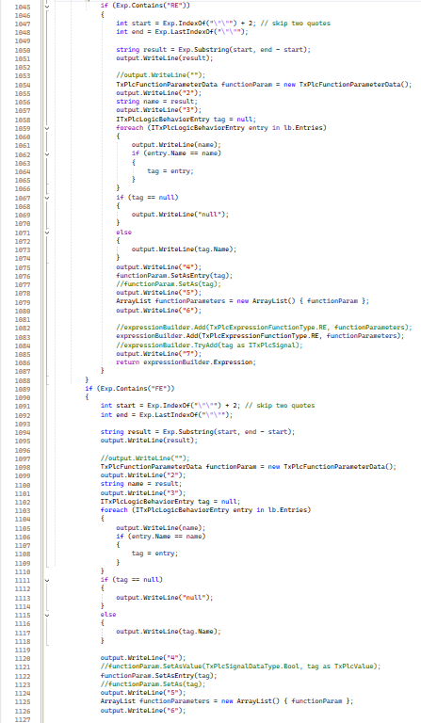
In Above code check the expression type for “RE” and “FE” and using “TxPlcExpressionBuilder” object create the expression.
Result In PS:
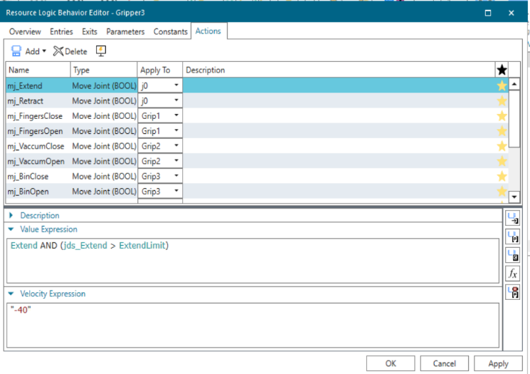
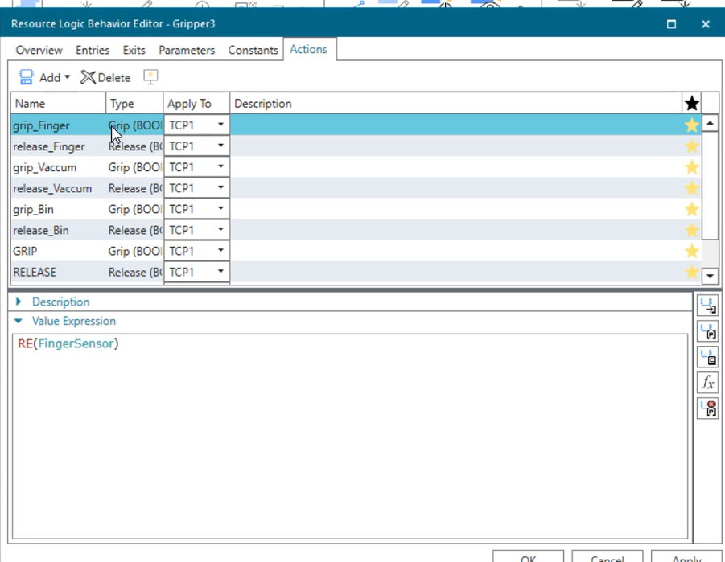

Reference Link For Constant creation Method : Tecnomatix.NET API
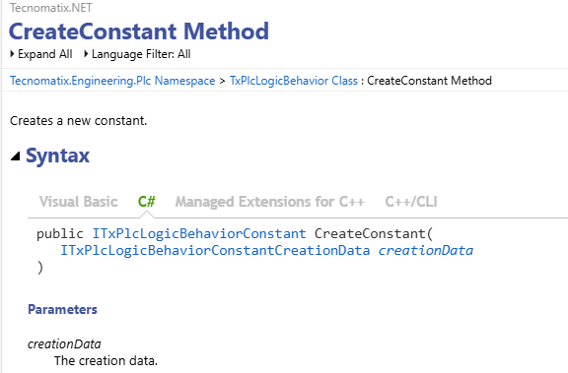
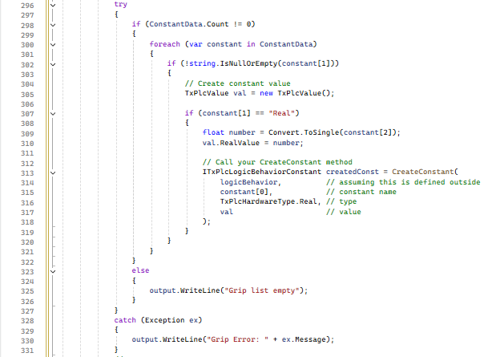
For create constant pass the data from list using loop and call “CreateConstant” method and, using “ITxPlcLogicBehaviorConstant” access the properties
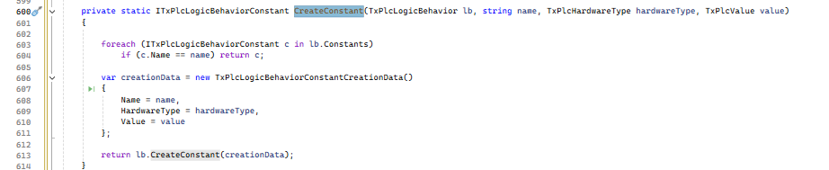
Assign the constant data to “TxPlcLogicBehaviorConstantCreationData” object.

Result In PS:

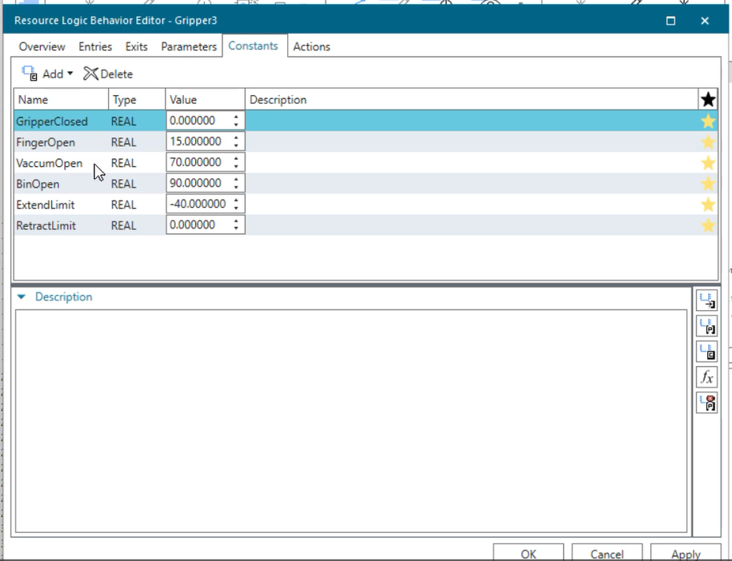
Create Constant In PS.

Create Parameter Reference Link : PL20231017544579710 Documentation
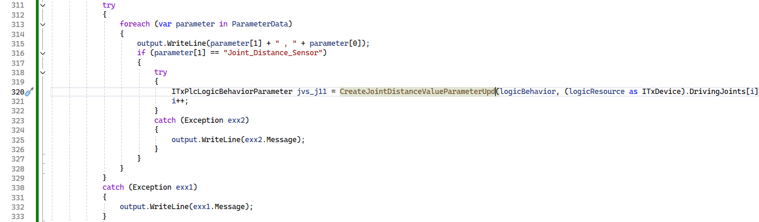
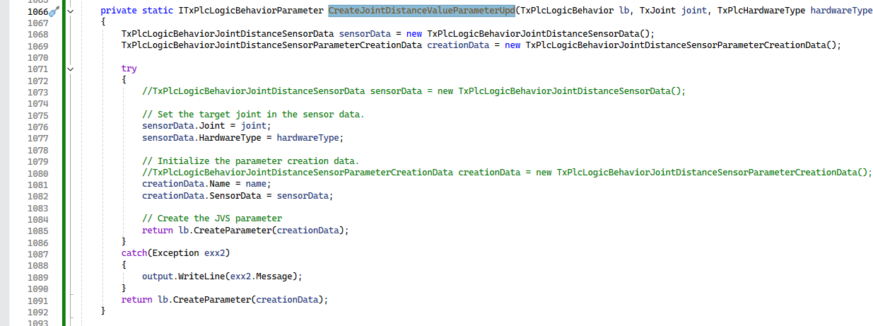
Using excel data pass the parameter value using loop
Using “LogicBehaviour.CreateParameter” create the parameters for Logic Behaviour.

Result In PS:
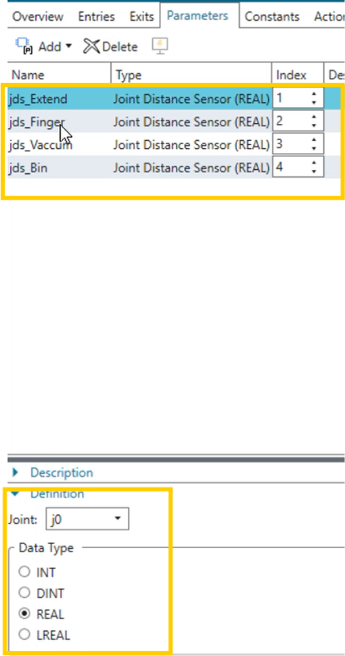

Overview:
The automation performs the following actions:
- Accesses the Virtual Desktop after launching via Edge.
- Opens the Clipboard inside the VDI.
- Copies data from a local Excel file.
- Deletes any existing data in virtual CSV.
- Pastes new data from the clipboard.
- Opens script.cs, copies the code.
- Launches PS VC Lite inside the VDI.
- Selects the target project and pastes the script.cs code.
- Executes the script successfully.

Functionality & Code Flow (with Screenshots)
  - Main Method:
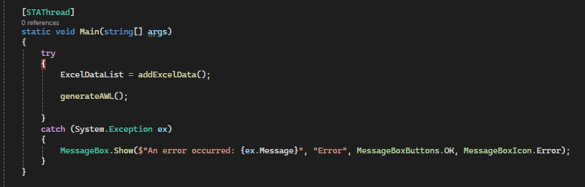
  - generateAWL () Method : It access the PS Simens Login Website.
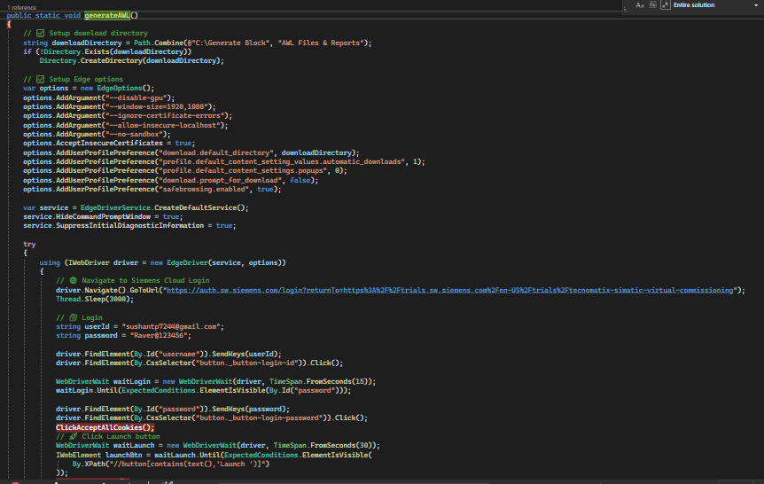

  - CopyExcelDataListToClipboardAndRunSikuli() Method: It Copy Excel Data from Local File To Virtual Clipboard.

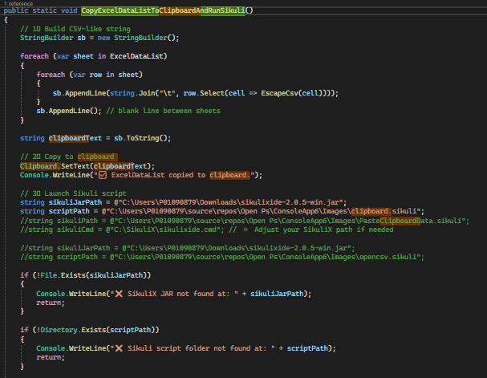
  - Opencsv() Method: It used to open csv from virtrual Desktop and paste data from clipboard.
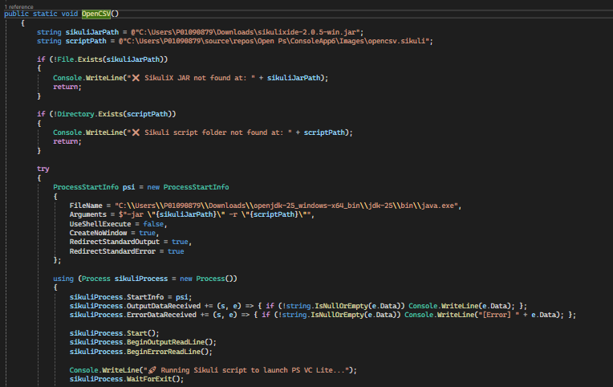

5.Opencs () Method: It Opens Script file of virtual desktop and copy this script and paste after opening the PS VC App.
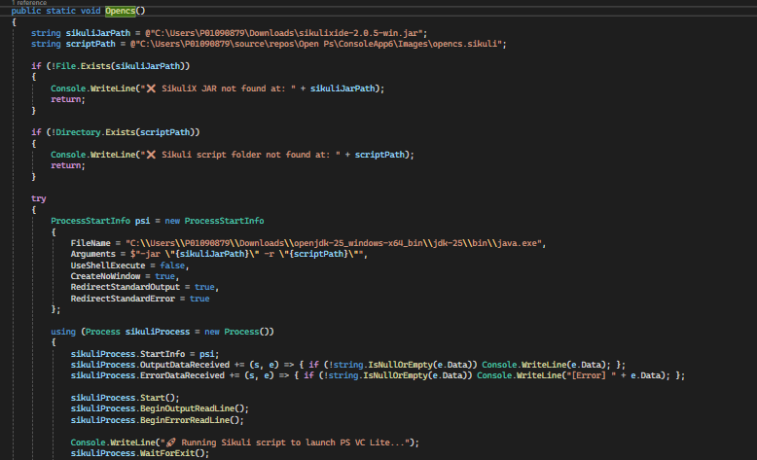

6. LaunchPSVCFromVDI() Method: It Launch Application and select Project then copy script in it and execute it successfully.
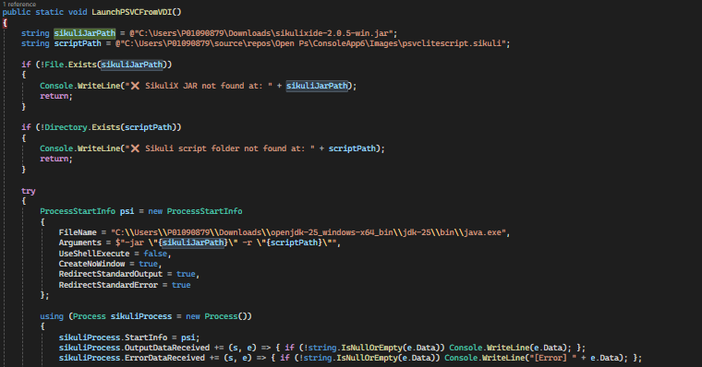

Updated By Sushant Y. Patil.

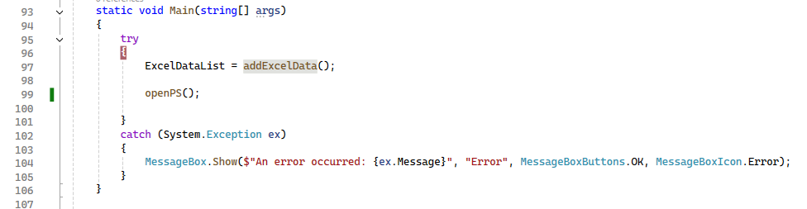
In above code Main() function call ExcelDataList = addExcelData(); function is responsible for access excel data and store in the list And OpenPS() function is responsible for access PS UI component.

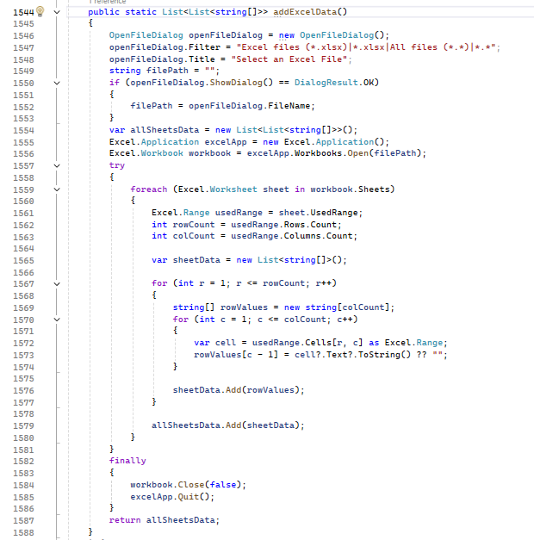
public static List<List<string[]>> addExcelData() is responsible for open pop up for excel sheet input using OpenFileDialog openFileDialog = new OpenFileDialog(); object and read the data as per the sheet using
Excel.Application excelApp = new Excel.Application();
Excel.Workbook workbook = excelApp.Workbooks.Open(filePath); objects and return the list of sheet array data.
var allSheetsData = new List<List<string[]>>();
allSheetsData.Add(sheetData);

Result :

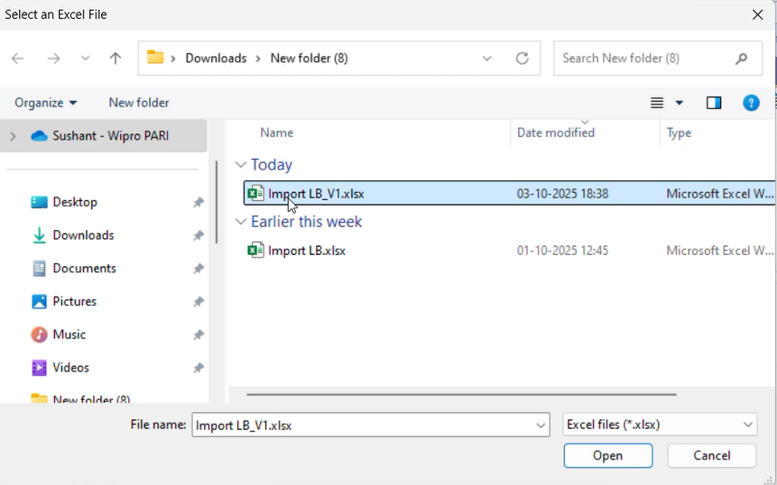
POP UP For Select Excel File.

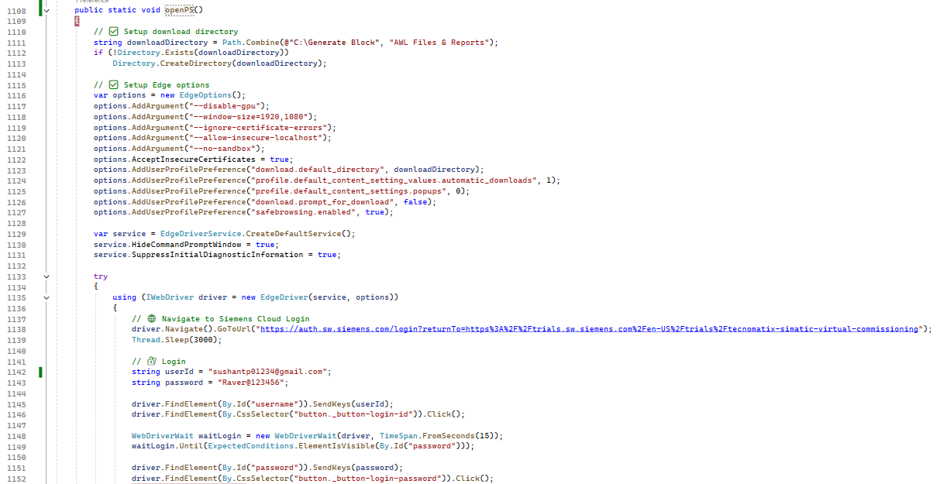

In openPS() method contains the logic for access the edge browser using using (IWebDriver driver = new EdgeDriver(service, options)) object and launch the URL using driver.Navigate().GoToUrl(); method, access pass USER EMAIL, PASSWORD using
driver.FindElement(By.Id("username")).SendKeys(userId);
driver.FindElement(By.CssSelector("button._button-login-id")).Click();

WebDriverWait waitLogin = new WebDriverWait(driver, TimeSpan.FromSeconds(15));
waitLogin.Until(ExpectedConditions.ElementIsVisible(By.Id("password")));

and click login button.

Result:
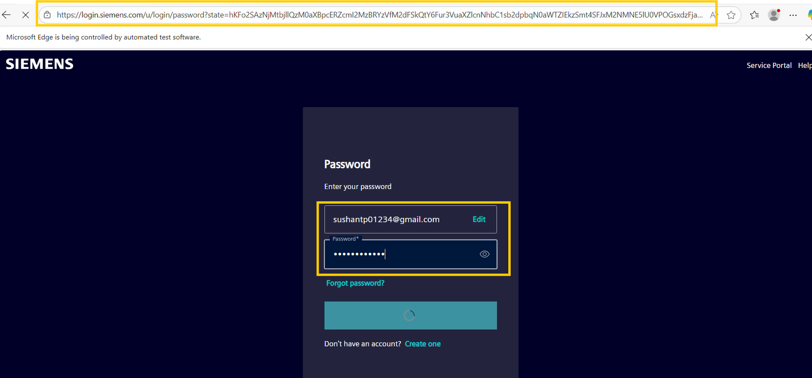
Access URL and add USER EMAIL, PASSWORD

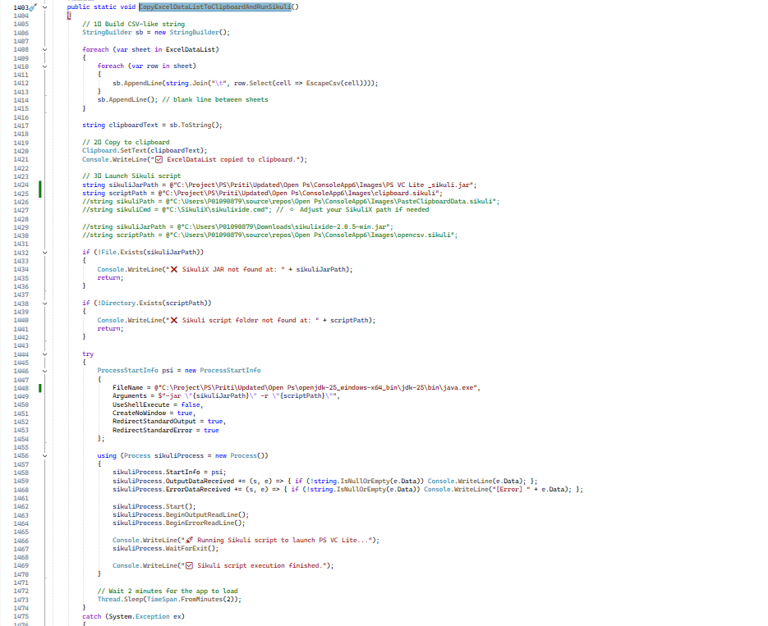
CopyExcelDataListToClipboardAndRunSikuli() method contains the logic to add the data in PS virtual environment clipboard.
Using StringBuilder sb = new StringBuilder(); class add the list data as per the input csv format.

Result:
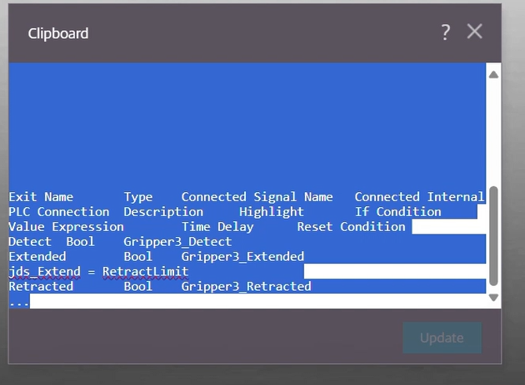

Add Excel Data In PS Virtual Environment Clipboard and Copy.

